A

Major Project

On

## “VÉRITÉ ROYALE”

In Partial Fulfillment for the award of the Degree Of Master’s Of Computer Application(MCA)

With Cloud Computing & Full Stack Development(IBM)



*Under The Guidance Of: Submitted By:*

Pro. Dr. Deepak Dembla Jatin Rajoria

Ms. Rashi Jain 23MCAN0230

(Assistant Professor)

**Department of Computer Application JECRC UNIVERSITY, JAIPUR**

**2023-2025**

# CANDIDATE DECLARATION

I hereby declare that the project work titled **“VÉRITÉ ROYALE”**, submitted as part of my academic requirement, is a record of my own work carried out under the guidance of Prof. Deepak Dembla. This project has been completed in partial fulfillment of the requirements for Master Of Computer Application at JECRC University.

I further declare that this project has not been submitted to any other university or institution for the award of any degree, diploma, or certificate. All sources of information and data used in this project have been acknowledged appropriately.

I understand that any breach of this declaration will result in the rejection of this project and disciplinary action.

### Name of the Student:

Jatin Rajoria

### Roll Number:

23MCAN0230

### Course and Semester:

Master Of Computer Application, 3rd Semester.

**Name(s) of Supervisors(s)/Guide(s) :**

Prof. Dr. Deepak Dembla

Ms.Rashi Jain

(Assistant Professor)

**Submission Date:**

**Signature:**

**JECRC UNIVERSITY**

**Department of Computer Application Major Project Completion Certificate**

This is to certify that ___________________________________________________Registration

No____________________________________has successfully completed the Major Project as a Part of the requirement for the Master of Computer Application (MCA) Program at JECRC UNIVERSITY, Jaipur, India.

Project Tittle: VÉRITÉ ROYALE

Technology Used: React JS, Node.JS, Express JS, MongoDB

Project Supervisor:

This project demonstrates student’s ability to apply theoretical knowledge gained during his/her academic to practical real-world scenarios. His/her dedication, hard work, and proficiency in the subject matter is commendable.

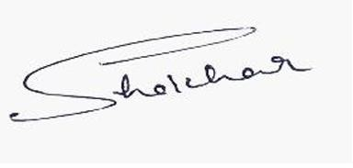

Mr. Shekhar Chander Project Supervisor

HoD

# ACKNOWLEDGEMENT

I am sincerely grateful to everyone who contributed to the successful completion of my project,

### "VÉRITÉ ROYALE"

First and foremost, I would like to express my heartfelt gratitude to my project guide, Prof. Dr. Deepak Dembla and Ms. Rashi Jain (Assistant Professor), for their invaluable guidance, encouragement, and support throughout this project. Their expertise and constructive feedback helped me refine my ideas and bring this project to fruition.

I would also like to thank the faculty members of **Department of Computer Applications** at **JECRC University** for providing me with the knowledge and resources necessary to undertake this project.

Additionally, I am deeply thankful to my classmates and friends for their collaboration and suggestions, which enhanced the scope and quality of my work.

Finally, I would like to extend my appreciation to my family for their unwavering support and encouragement during this project. Their belief in my abilities kept me motivated and focused throughout the development process.

This project has been an invaluable learning experience, and I am truly thankful for all the support I have received.

# TABLE OF CONTENT

|  |  |  |
| --- | --- | --- |
| **SR. No** | **Section** | **Page No.** |
| **1** | Cover Page | 1 |
| **2** | Declaration | 2 |
| **3** | Acknowledgement | 4 |
| **4** | Problem Definition | 7 |
| **5** | Objective | 10 |
| **6** | System Study | 11 |
| **7** | System Analysis | 20 |
| **8** | System Development Cycle | 27 |
| **9** | Data Dictionary | 30 |
| **10** | Source Code | 40 |
| **11** | Limitation And Future Enhancements | 58 |

**ABSTRACT**

**Vérité Royale: A Luxury Perfume Brand**

Vérité Royale is a cutting-edge luxury perfume brand, seamlessly integrating tradition with modernity through an innovative web platform. Crafted using state-of-the-art technologies such as ReactJS, Express JS, NodeJS, and powered by a robust MongoDB database, the brand redefines the luxury fragrance experience in the digital age. Each scent is a sophisticated blend of heritage and contemporary artistry, carefully designed to evoke deep emotions and exude timeless elegance. With a commitment to exclusivity and prestige.

Vérité Royale has earned a reputation as a creator of iconic perfumes that tell captivating stories while appealing to a discerning global audience. The brand’s digital presence enhances its ability to reach and engage with perfume connoisseurs worldwide, offering a seamless, luxurious experience both online and offline. Operated by a passionate and skilled team.

Verité Royale is a distinguished luxury perfume brand that embodies the essence of timeless elegance, sophistication, and artistry. Known for its meticulous craftsmanship and exclusive compositions, Verité Royale curate's scents that evoke a sense of rare opulence and sensory indulgence.

Each fragrance is created with an emphasis on the highest quality ingredients, blending traditional perfumery techniques with innovative, contemporary design. The brand’s commitment to authenticity and refinement makes it a symbol of prestige in the world of haute fragrance. With a collection that speaks to the desires of the discerning elite, Verité Royale offers a sensory journey that transcends the ordinary, leaving an indelible mark of luxury on those who experience it.

# Problem Definition

# 1.1 INTRODUCTION

**Project: Vérité Royale: A Luxury Perfume Brand**

Vérité Royale is a luxury perfume brand that expertly blends tradition with modern innovation to create fragrances that evoke emotions and exude sophistication. With a focus on using only the finest ingredients, each fragrance is meticulously crafted to offer an unforgettable sensory experience. The brand combines its rich heritage in perfumery with cutting-edge web technologies to offer a seamless, luxurious online shopping experience, making its exclusive scents accessible worldwide. Vérité Royale’s collections range from timeless signature scents to rare limited editions, all designed to embody elegance and prestige, allowing fragrance connoisseurs to indulge in the art of fine perfumery at their fingertips.

**A Legacy of Luxury**

Vérité Royale’s commitment to excellence is evident in every aspect of its perfumery. Each fragrance is a masterfully crafted composition, created with the finest, hand-selected ingredients sourced from around the world. The brand’s artisans blend these rare materials with precision and care, forming a symphony of notes that captivate and engage the senses. From the initial burst of invigorating top notes to the complex heart notes and the deep, lingering warmth of the base, each layer of a Vérité Royale fragrance is designed to tell a story and elevate the olfactory experience. It’s a journey that begins with fresh elegance and evolves into a regal warmth that stays with the wearer, leaving an indelible impression of luxury.

This meticulous approach to fragrance creation ensures that every Vérité Royale perfume is not just a scent, but a refined experience. The brand’s dedication to craftsmanship transforms each bottle into a work of art, offering fragrances that transcend trends and time. Whether it’s the vibrant freshness of a floral blend or the sophisticated richness of an oriental accord, Vérité Royale’s perfumes evoke emotions and memories, wrapping the wearer in an aura of sophistication and exclusivity. With each fragrance, the brand redefines luxury, providing a truly regal experience that captures the essence of refinement and elegance.

**Elevating the Luxury Shopping Experience**

In addition to its exceptional fragrances, Vérité Royale is deeply committed to offering a seamless and refined online shopping experience that mirrors the sophistication of its products. By leveraging advanced web technologies, the brand has developed an elegant, user-friendly platform that allows customers to explore and purchase its exclusive perfumes with ease and convenience. The website provides an intuitive interface where each fragrance is presented with detailed descriptions, helping customers make informed decisions while enjoying a curated, luxurious browsing experience. Whether you're seeking to indulge in a new signature scent, discover a limited-edition masterpiece, or simply elevate your everyday moments with a touch of refinement, Vérité Royale's online store embodies the same sophistication and exclusivity found in its perfumes. This blend of modern convenience with timeless luxury ensures that every interaction with the brand feels special, personalized, and indulgent.

**1.2 NEED**

1. **Bridging Tradition and Innovation:**  
   Vérité Royale meets the growing demand for fragrances that blend traditional craftsmanship with modern innovation. The brand creates timeless, luxurious scents while embracing cutting-edge technology to enhance the customer experience, offering both heritage and modernity in a single product.
2. **Exclusivity and Prestige:**  
   As the luxury market continues to expand, there is an increasing desire for exclusive, high-quality perfumes that embody sophistication and status. Vérité Royale offers a collection of signature and limited-edition fragrances that appeal to those seeking exclusivity and a sense of prestige in their personal scent.
3. **Sophisticated Online Shopping Experience:**  
   With the rise of e-commerce, there is a growing need for luxury brands to provide seamless, high-end online shopping experiences. Vérité Royale's advanced digital platform ensures that customers can explore, discover, and purchase luxury perfumes with ease, making the brand more accessible to a global audience while maintaining a refined, exclusive feel.
4. **Customization and Personalization:**  
   As consumers increasingly seek personalized experiences, Vérité Royale offers curated collections that cater to diverse tastes, allowing customers to find their ideal signature scent. The online platform provides detailed fragrance descriptions and recommendations, enabling a tailored shopping experience.
5. **High-Quality, Sustainable Ingredients:**  
   The demand for transparency and sustainability in luxury products is rising. Vérité Royale uses only the finest, responsibly sourced ingredients in its perfumes, addressing consumer preferences for ethically created, premium products that prioritize both luxury and sustainability.
6. **Emotional and Sensory Appeal:**  
   Vérité Royale’s fragrances are crafted to evoke deep emotions and create lasting memories. As people seek products that offer more than just functionality, the emotional connection that a luxury fragrance can establish adds significant value to the brand, making it a desirable choice for those who appreciate artistry and sensory experiences.
7. **Global Reach of Luxury Perfumery:**   
   Vérité Royale meets the growing global demand for high-end perfumes, expanding the accessibility of luxury fragrances. Its innovative platform allows customers worldwide to indulge in exclusive scents from a brand that brings true luxury to their fingertips.

# 1.3 Purpose

# Reinventing Luxury Perfumery: To redefine the luxury perfume industry by blending traditional craftsmanship with

# modern innovation, creating exceptional fragrances that evoke emotions and embody sophistication.

# Timeless Elegance: To craft iconic, timeless perfumes that resonate with individuals who seek to express their unique style, elevating everyday moments through refined scents.

# Commitment to Quality: To use only the finest, responsibly sourced ingredients in the creation of every fragrance, ensuring that each scent is a luxurious, high-quality work of art.

# Enhancing the Customer Experience: To provide a seamless and refined online shopping experience, making luxury accessible while maintaining exclusivity and personalization for customers worldwide.

# Global Accessibility: To expand the reach of luxury perfumery by offering exclusive fragrances online, allowing customers from around the world to indulge in Vérité Royale's artistry and sophistication.

# Building a Legacy of Excellence: To create a lasting legacy in the world of luxury perfumery, setting new standards for quality, craftsmanship, and customer experience.

# Personalized Luxury Experience: To offer curated collections and personalized fragrance recommendations that cater to the diverse tastes and preferences of customers, ensuring a tailored and meaningful shopping experience.

# Embodying Prestige and Exclusivity: To offer fragrances that not only captivate the senses but also reflect a sense of prestige, exclusivity, and luxury, elevating the everyday lives of those who wear them.

# 2. OBJECTIVE

Vérité Royale is developed with the primary aim of transforming the luxury perfume industry by offering an innovative, streamlined, and user-friendly platform for perfume enthusiasts, collectors, and connoisseurs. The objectives of this brand are designed to address the challenges faced by perfume lovers in accessing high-quality, exclusive fragrances while ensuring a more refined, efficient, and personalized shopping experience. Vérité Royale aims to redefine the luxury perfume experience through the following key objectives:

1. **Crafting Timeless, Iconic Fragrances:**  
   To create high-quality, unique perfumes that combine traditional craftsmanship with modern innovation, offering fragrances that evoke emotion, sophistication, and long-lasting impressions.
2. **Enhancing Customer Experience:**  
   To provide a seamless, intuitive online shopping platform that allows customers to explore, discover, and purchase luxury perfumes with ease, ensuring an elevated and personalized shopping journey.
3. **Ensuring Global Accessibility:**  
   To make exclusive, high-end fragrances accessible to customers worldwide by offering a refined online experience that bridges the gap between luxury and convenience.
4. **Offering Exclusive and Curated Collections:**  
   To offer a carefully curated selection of signature and limited-edition fragrances, ensuring a unique and tailored experience for every customer, from fragrance enthusiasts to those new to the world of luxury perfumery.
5. **Promoting Luxury and Exclusivity:**  
   To maintain an air of exclusivity by offering rare, limited-edition perfumes that provide customers with a one-of-a-kind, luxurious experience, elevating their personal style.
6. **Commitment to Quality and Sustainability:**  
   To ensure that each fragrance is crafted using the finest, ethically sourced ingredients, prioritizing both quality and sustainability in every product.
7. **Building a Legacy of Excellence:**  
   To establish Vérité Royale as a global leader in luxury perfumery, known for its innovation, craftsmanship, and dedication to providing an exceptional customer experience that sets new standards in the industry.
8. **Creating Emotional Connections Through Fragrance:**  
   To design perfumes that do more than just smell beautiful—offering emotional and sensory experiences that resonate deeply with customers, creating lasting memories and connections to the brand.

**3. System Study**

**3.1. Feasibility Study**

**3.1.1. Economic Feasibility:**

Economic feasibility assesses whether Vérité Royale is financially viable, comparing the development and operational costs against the expected benefits. The goal is to ensure that the brand’s luxury perfumes, online platform, and business model will generate a strong return on investment while remaining financially sustainable.

**1. Development Costs:**

The initial development costs for Vérité Royale involve creating a high-quality product line, establishing the online platform, and setting up the necessary infrastructure. Expenses include hiring expert perfumers, product development, sourcing high-quality ingredients, branding, and web development. By leveraging advanced web technologies like ReactJS, NodeJS, and cloud hosting solutions, development costs are optimized, reducing the need for extensive physical infrastructure and streamlining the overall process.

**2. Maintenance Costs:**

After launch, the brand will incur ongoing costs for website maintenance, product updates, inventory management, and marketing. Regular updates and enhancements to the platform are essential to ensure a seamless customer experience. Cloud-based hosting will further reduce operational overheads, offering scalability and reliability. Additionally, customer support and brand marketing efforts will require a dedicated budget to maintain and grow the customer base over time. These costs are designed to be manageable and scale in proportion to the brand’s growth.

**3. Return on Investment (ROI):**

The expected benefits of Vérité Royale include significant profit margins from the sale of high-end perfumes, strong brand loyalty, and increased customer lifetime value. The luxury perfume market is growing globally, and with a unique position in the market offering exclusive, high-quality fragrances, Vérité Royale is positioned to capture a premium segment. The brand’s online presence reduces the need for physical retail space, lowering operating costs while reaching a global audience. The expected ROI is substantial due to the brand's premium pricing, personalized customer experience, and exclusive collections that drive both direct sales and brand recognition.

**3.1.2. Feasibility Study**

A feasibility study for Vérité Royale evaluates whether the luxury perfume brand can be successfully executed, considering key factors such as technical, operational, economic, and market aspects. The study serves the following purposes:

1. **Risk Mitigation:**  
   Identifies potential challenges early (e.g., market competition, supply chain issues) and provides strategies to address them, reducing the likelihood of failure.
2. **Resource Optimization**:   
   Ensures efficient use of resources (technology, budget, personnel) through cloud-based infrastructure, advanced web technologies, and effective deployment of skilled professionals.
3. **Informed Decision-Making**:  
   Provides stakeholders with insights into the brand’s viability, helping make confident decisions based on clear market demand, trends, and financial projections.
4. **Market Demand and Positioning**:  
   Assesses customer preferences and market trends, ensuring Vérité Royale’s products meet demand and are well-positioned in the luxury fragrance sector.
5. **Operational Feasibility:**  
   Evaluates the logistics of sourcing ingredients, production, inventory management, and the scalability of the online platform to ensure smooth business operations.
6. **Economic Feasibility**:  
   Compares development costs to projected returns, ensuring the project is financially viable with strong ROI, while maintaining financial sustainability in the luxury market.

**3.1.3. Operational Feasibility**

Operational feasibility assesses whether the day-to-day operations of Vérité Royale can be successfully implemented and managed effectively. It focuses on evaluating whether the brand’s operational systems, processes, and resources can support its business model and ensure smooth and efficient delivery of services. The key aspects of operational feasibility for Vérité Royale include:

1. **Supply Chain and Sourcing:**  
   Vérité Royale will source premium, high-quality ingredients for its perfumes, ensuring a consistent supply of materials. Operational feasibility assesses the efficiency and reliability of suppliers and manufacturers, as well as logistics for inventory management, packaging, and delivery. This ensures the perfumes are produced and delivered without delays, maintaining brand standards.
2. **Production and Quality Control:**  
   To ensure each fragrance meets the highest standards, Vérité Royale will implement strict quality control measures during the production process. This includes sourcing ingredients from trusted suppliers, conducting regular product testing, and maintaining consistency in scent profiles, packaging, and presentation. The study ensures that production capabilities can scale with growing demand while maintaining quality.
3. **Online Platform and Customer Experience:**  
   Vérité Royale’s online platform will serve as the primary sales channel. The operational feasibility includes evaluating the platform's user experience, functionality, and scalability. It will ensure smooth navigation, secure payment processing, and seamless order fulfillment. Additionally, customer service operations, including handling inquiries and returns, will be assessed to provide an exceptional customer experience.
4. **Inventory Management and Fulfillment:**  
   Effective inventory management systems are crucial for tracking stock levels, forecasting demand, and preventing stockouts or overstocking. The operational feasibility study will assess inventory management tools, integration with the online platform, and the efficiency of fulfillment processes (e.g., warehousing and shipping) to ensure timely delivery.
5. **Scalability:**  
   As Vérité Royale grows, the operations need to scale efficiently. The operational feasibility includes assessing whether current infrastructure, such as cloud-based solutions and logistics systems, can handle increased demand without sacrificing quality or customer satisfaction. It ensures the platform and backend systems are adaptable and scalable.
6. **Staffing and Expertise:**  
   The study will evaluate the availability of skilled personnel to support various functions of the business, including product development (perfumers and designers), marketing, customer service, and operations management. The ability to hire and manage a talented workforce is essential to maintaining high standards and ensuring smooth day-to-day operations.
7. **Regulatory Compliance and Legal Considerations**:  
   Vérité Royale must comply with regulations related to product safety, labelling, and international shipping standards. Operational feasibility includes ensuring compliance with cosmetic and fragrance industry regulations in different regions, minimizing legal risks.

**3.1.4. Technical Feasibility**

Technical feasibility assesses whether the technological infrastructure required to support Vérité Royale’s operations can be implemented and maintained effectively. It focuses on evaluating the systems, tools, and resources necessary to build and manage the brand’s online presence, production capabilities, and customer engagement. Key aspects of technical feasibility for Vérité Royale include:

1. **E-Commerce Platform Development:**  
   Vérité Royale will leverage modern, scalable technologies to build a robust online store. This involves using web technologies such as ReactJS, NodeJS, and MongoDB to create a seamless, secure, and user-friendly e-commerce platform. The technical feasibility study will ensure the platform can handle high traffic, secure transactions, and customer data privacy, with future scalability to support growth.
2. **Integration of Payment Systems:**  
   The platform will need to integrate secure and efficient payment gateways such as PayPal, Stripe, or credit card processing systems. The study will ensure that the payment system can handle different currencies, provide a smooth transaction experience, and meet security standards (e.g., PCI-DSS compliance) to protect customer data.
3. **Security and Data Protection:**  
   Security is crucial for both customer trust and compliance. The technical feasibility will ensure that the platform follows best practices for data security, including SSL certificates, data encryption, and firewalls to protect sensitive customer information. It will also evaluate the compliance of the platform with data protection regulations such as GDPR (General Data Protection Regulation) or other region-specific privacy laws.
4. **Mobile Optimization and Responsiveness:**  
   As mobile shopping continues to rise, the platform must be fully optimized for mobile devices. The technical feasibility study will ensure the website is responsive, providing an optimal shopping experience on smartphones and tablets, ensuring that customers can browse, explore, and purchase perfumes seamlessly from any device.
5. **Third-Party Integrations:**  
   Vérité Royale may require third-party services for specific functions, such as shipping providers, loyalty programs, or email marketing. The study will evaluate whether these third-party tools can be easily integrated into the platform, ensuring smooth operations and enhanced functionality.

**3.1.5. Motivational Feasibility**

1. **Passion for Craftsmanship and Quality:**  
   The founders and team at Vérité Royale are deeply dedicated to creating perfumes that exemplify luxury, artistry, and sophistication. This shared passion for fine perfumery drives the team to continuously innovate, ensuring that every fragrance upholds the brand's commitment to exceptional quality. Their enthusiasm for the craft fosters a sense of purpose and unity, motivating all involved to meet the brand’s high standards.
2. **Vision and Brand Identity:**  
   Vérité Royale's vision to redefine the luxury fragrance industry with exclusive, timeless perfumes is a compelling motivator for both the internal team and external customers. The brand identity, grounded in elegance, exclusivity, and artistry, resonates deeply with customers, inspiring loyalty. This strong, clear vision drives the team to push creative boundaries, ensuring that each new fragrance and experience exceeds expectations and builds the brand’s reputation.
3. **Customer-Centric Approach:**  
   The commitment to offering personalized, high-touch customer service is a key driver for motivation across the organization. Vérité Royale’s goal of making luxury fragrances accessible while maintaining an air of exclusivity encourages the team to craft a seamless, engaging shopping experience. A focus on customer satisfaction, whether through tailored scent recommendations or prompt service, fosters strong relationships and builds enthusiasm within the team to meet and exceed customer expectations.
4. **Market Demand and Growth Potential:**  
   The global appetite for luxury goods, especially in the perfume sector, serves as a significant motivator for investors, stakeholders, and the internal team. As demand for premium fragrances continues to rise, Vérité Royale’s growth potential within the expanding online luxury market energizes the team. This optimism about future growth drives innovation, pushing the brand to develop new collections and explore new markets, ensuring continued momentum and long-term success.
5. **Building a Lasting Legacy:**  
   Vérité Royale aims to create a timeless legacy in luxury perfumery, defined by exceptional craftsmanship and elegance. This vision inspires the team to stay focused, dedicated, and passionate, ensuring the brand’s enduring success and global recognition. about the brand’s success.
6. **3.1.6. Schedule Feasibility**

Schedule feasibility assesses whether Vérité Royale can meet its established deadlines and launch milestones while ensuring that all required tasks are completed on time. This involves evaluating the project timeline, determining key deliverables, and ensuring that the team can realistically complete the necessary work within the given time frame. For Vérité Royale, schedule feasibility is crucial for both the development of its online platform and the execution of its marketing, production, and distribution strategies. Key factors of schedule feasibility for Vérité Royale include:

1. **Platform Development Timeline:**  
   The development of Vérité Royale’s e-commerce platform, including web design, integration of payment gateways, inventory systems, and customer management tools, will be a critical component of the timeline. The project needs to be completed in phases, with clear deadlines for the completion of each feature (e.g., user interface, payment systems, inventory integration). A detailed schedule will ensure that all elements of the platform are ready for launch within an agreed timeframe, allowing enough time for testing and quality assurance.
2. **Fragrance Production and Sourcing:**  
   To launch a collection of luxury fragrances, Vérité Royale needs to source high-quality ingredients, work with perfumers, and finalize the formulations for its initial product lineup. The production timeline must account for sourcing, crafting, packaging, and quality control, ensuring that the first batch of perfumes is ready in time for the website launch. The feasibility study will assess the lead times for raw materials and collaboration with suppliers to ensure timely production.
3. **Marketing and Brand Launch Activities:**  
   Vérité Royale’s marketing and brand launch are crucial for creating awareness and driving initial sales. The schedule must allow for the development of a marketing plan, including content creation, social media campaigns, influencer partnerships, and public relations efforts. A well-structured timeline will help align the marketing efforts with the e-commerce platform launch, creating a coordinated approach to reach target audiences and build brand recognition. Campaigns should be designed to ramp up ahead of the official launch date.
4. **Logistics and Distribution Setup:**  
   Efficient logistics and distribution channels are essential for ensuring that Vérité Royale can fulfill orders promptly. The schedule will need to account for setting up relationships with shipping partners, configuring inventory management systems, and establishing warehousing. The feasibility study will ensure that the logistics process, from order receipt to shipping, is streamlined to meet customer expectations regarding delivery timeframes.
5. **Post-Launch Activities and Continuous Improvement:**  
   After the official launch, Vérité Royale’s schedule must include time for collecting customer feedback, making adjustments, and improving the platform. Post-launch activities will also involve monitoring performance metrics, analyzing sales data, and addressing any technical issues that may arise. The schedule will need to allocate resources for ongoing site maintenance, customer service, and inventory management to ensure a smooth experience for customers and continued growth for the brand.

**3.2. Cost and Benefit Analysis for Vérité Royale**

A **Cost and Benefit Analysis** is crucial for assessing the financial viability and strategic value of Vérité Royale, helping stakeholders understand the projected costs, the potential returns, and the overall sustainability of the business model. Below is a detailed breakdown of the anticipated costs and benefits associated with the launch and operation of Vérité Royale, a luxury perfume brand.

**3.2.1. Cost Analysis**

**Initial Development Costs:**

1. **Website and E-Commerce Platform Development:**  
   The cost of building a seamless and secure online store, including web development (ReactJS, NodeJS), UI/UX design, integration of payment systems, and database setup (MongoDB). Estimated cost: $50,000 - $100,000.
2. **Branding and Design:**  
   Developing a strong, elegant brand identity, including logo design, packaging, and promotional materials. Estimated cost: $20,000 - $30,000.
3. **Fragrance Creation and Production:**  
   Costs associated with sourcing raw materials, working with perfumers, and manufacturing the initial batch of luxury perfumes. Includes R&D for unique fragrances. Estimated cost: $100,000 - $150,000 for initial production and formulation.
4. **Marketing and Advertising:**  
   Initial marketing campaigns, including influencer collaborations, social media marketing, and traditional media (print, PR). Estimated cost: $50,000 - $80,000 for the first 6 months.
5. **Legal and Compliance Fees:**  
   Legal fees for trademarks, patents, brand protection, and compliance with regulations (e.g., data protection). Estimated cost: $10,000 - $15,000.

**Ongoing Operational Costs:**

1. **Platform Maintenance and Hosting:**  
   Monthly costs for cloud hosting (e.g., AWS, Google Cloud), platform maintenance, software updates, and technical support. Estimated cost: $5,000 - $10,000 per month.
2. **Inventory Management and Fulfillment:**  
   Costs related to warehousing, shipping, and fulfillment, including partnership with logistics companies. Estimated cost: $10,000 - $20,000 per month, depending on order volume.
3. **Staffing and Salaries:**  
   Salaries for key team members, including marketing professionals, customer support, operations, and administrative staff. Estimated cost: $100,000 - $200,000 annually.
4. **Customer Acquisition and Retention:**  
   Costs for paid advertising, loyalty programs, and customer retention initiatives. Estimated cost: $30,000 - $50,000 annually.

|  |  |  |
| --- | --- | --- |
| **Category** | **Estimated Costs (Year 1)** | **Estimated Benefits (Year 1)** |
| **Initial Development (Platform, Branding, Production, etc.)** | $230,000 - $375,000 |  |
| **Ongoing Operational Costs (Platform, Staff, Inventory)** | $300,000 - $500,000 annually | **Revenue from Sales:** $500,000 - $1,000,000 |
| **Marketing, Advertising, and Brand Building** | $80,000 - $130,000 | **Recurring Revenue (Subscriptions):** $50,000 - $150,000 |
| **Legal, Compliance, Miscellaneous** | $30,000 - $50,000 | **Brand Recognition & Equity:** Growing, with potential global expansion |
| **Total Estimated Costs** | **$640,000 - $1,055,000** | **Total Estimated Revenue:** $550,000 - $1,150,000 |
| **Profit Margin in Year 1** |  | **Profit Potential:** Positive in Year 1 due to high-margin luxury products |

**3.2.2. Benefit Analysis**

The benefits of Vérité Royale can be categorized into tangible and Intangible:

1. **Tangible Benefits**

* **Premium Pricing & High Margins**: As a luxury brand, Vérité Royale enjoys premium pricing and high profit margins, generating ₹50,00,000 to ₹1,00,00,000 annually.
* **Brand Loyalty & Repeat Sales**: Quality and customer satisfaction foster repeat purchases, with an estimated 60-70% retention rate.
* **International Expansion**: Potential global reach, increasing revenue by ₹30,00,000 to ₹50,00,000 within 2-3 years.
* **Efficient Operations**: Streamlined supply chain reduces costs, saving ₹1,50,000 to ₹2,50,000 annually.

1. **Intangible Benefits**

* **Brand Prestige**: VÉRITÉ ROYALE becomes synonymous with luxury and sophistication, elevating consumer perceptions.
* **Emotional Connection**: Unique scents create a deep emotional bond, enhancing brand loyalty.
* **Cultural Impact**: Sets trends in luxury, promoting sustainability and exclusivity.
* **Enhanced Customer Experience**: Personalization and exclusive packaging enhance customer satisfaction.
* **Aspirational Appeal**: The brand’s luxury status attracts high-net-worth individuals.

**Return on Investment (ROI)**

Vérité Royale is expected to recover its initial investment within 1.5–2 years, with strong profits from high margins, brand loyalty, and global expansion.

**3.3. Fact Findings of Vérité Royale**

**1. Challenges in the Perfume Industry**

* **Saturated Market**: The luxury fragrance market is highly competitive, making differentiation a challenge.
* **Brand Loyalty**: Retaining customers is difficult due to changing preferences and brand-switching behaviour.
* **Supply Chain Issues**: Sourcing premium ingredients and managing consistent production is a challenge for smaller brands.
* **Sustainability Concerns**: Rising demand for eco-friendly practices adds complexity, particularly with high costs for sustainable materials.

**2. Customer Expectations**

* **Uniqueness & Personalization**: Consumers seek exclusive, custom fragrances that reflect individuality.
* **Premium Quality**: Expectation for high-quality ingredients and elegant packaging to match the brand’s luxury status.
* **Experiential Purchases**: Customers desire memorable, luxury experiences, not just a product.
* **Sustainability**: Growing demand for ethically sourced and sustainable products.

**3. Industry Trends & Opportunities**

* **Niche Fragrances**: Rising demand for unique, artisanal perfumes presents an opportunity for differentiation.
* **Digital Growth**: E-commerce and virtual consultations are essential for expanding brand reach.
* **Influencer Endorsements**: Collaborating with influencers and celebrities can boost brand visibility.
* **Emerging Markets**: Increasing demand for luxury goods in regions like Asia and the Middle East provides growth potential.

**4. Stakeholder Needs**

* **Retailers**: Seek exclusive, high-quality products that appeal to affluent customers.
* **Influencers**: Essential for brand awareness and building consumer trust.
* **Consumers**: Expect transparency, exceptional service, and sustainability.

**3.4. System Overview of Vérité Royale**

Vérité Royale is an innovative, integrated digital platform designed to enhance the luxury perfume brand's customer experience, brand management, and product distribution. The system connects key stakeholders, including customers, retailers, brand ambassadors, and supply chain partners, to streamline operations and foster stronger engagement. It addresses challenges such as personalized customer experiences, inventory management, e-commerce integration, and brand visibility

**3.4.1. System Components**

The Vérité Royale system is designed to provide an exceptional customer experience while managing operations effectively across various touchpoints such as e-commerce, inventory, CRM, and influencer collaborations. Below are the core system components of Vérité Royale:

**1. Frontend (User Interface)**

* **Customer Profile & Personalization**: Allows customers to create profiles, get personalized fragrance recommendations, and customize scents.
* **Product Catalogue & E-Commerce**: Displays perfumes for purchase, including exclusive collections and limited editions.
* **Exclusive Offers & Loyalty**: Features rewards, promotions, and VIP access for loyal customers.
* **Feedback System**: Enables customers to leave reviews and ratings, providing valuable insights into product satisfaction and helping the brand improve customer experience.

**2. Backend (Server-Side Processing)**

* **User Authentication**: Secure login and role-based access control for customers, retailers, and influencers.
* **Data Processing & Analytics**: Processes customer interactions and sales data for personalized recommendations and marketing.
* **Order Management**: Manages product orders, inventory, and automated reordering.
* **Notification System**: Sends personalized updates to customers, influencers, and retailers about promotions and stock levels.

1. **Database (Data Storage and Management)**

* **Customer Data**: Stores personal details, preferences, purchase history, and loyalty points.
* **Product Inventory**: Tracks stock levels, product variations, and limited-edition items.
* **Sales & Transactions**: Logs transaction data for targeted promotions and order history.
* **Brand Ambassadors Data**: Manages influencer partnerships, contracts, and campaign performance.
* **Sustainability Data**: Tracks sourcing and production methods for transparency and eco-conscious practices.

**3.4.2. Key Features of the System**

1. **Personalized Fragrance Recommendations:**

Vérité Royale offers a personalized fragrance discovery experience. Based on customer preferences, past purchases, and fragrance profiles, the system suggests unique and tailored scents, allowing customers to find their perfect fragrance effortlessly.

1. **Exclusive Limited-Edition Collections:**

The platform provides access to exclusive, limited-edition fragrances, ensuring that customers enjoy unique, high-quality products that enhance the sense of exclusivity and luxury associated with the brand.

1. **Custom Fragrance Creation:**

Vérité Royale allows customers to design bespoke perfumes, blending different notes and ingredients according to personal taste. This customization feature enhances customer engagement and provides a unique, personalized product offering.

1. **E-Commerce Integration and Seamless Checkout:**

The system integrates with an advanced e-commerce platform, offering a seamless shopping experience. Customers can easily browse, select, and purchase products with secure payment gateways, providing a smooth transaction process.

**3.4.3. System Architecture**

Vérité Royale follows a modern client-server architecture designed for scalability, performance and security. Key components include:

* **Frontend (Client-Side):** Built with React JS, Node JS, Express JS to provide a responsive and intuitive interface for users.
* **Backend (Server-Side):** Node.js (or Ruby on Rails, Django), Express.js, JWT/OAuth 2.0 for secure user authentication.
* **Database (Data Storage):** MongoDB for scalable, flexible, and unstructured data storage.
* **Real-Time Communication:** WebSocket or Firebase for real-time notifications and updates about inventory, new releases, and promotions.

**3.4.4. User Roles and Permissions**

Vérité Royale supports different user roles, each with its own set of permissions:

* **Admin:** Has full access to all features, including user management, data analytics, and system settings.
* **Brand/Marketing Manager:** Create and manage marketing campaigns, Oversee loyalty programs and exclusive offers.
* **Customer:** Access customer orders and history. Manage loyalty programs and coordinate deliveries.
* **Perfume Production & Inventory Manager:** Manage stock levels, inventory, and supplier relationships. Oversee quality control and product availability.

**3.4.5. System Benefits**

### Efficiency: Streamlines product management, order processing, and inventory for faster operations.

### Cost Savings: Optimizes inventory and marketing to reduce waste and maximize profitability.

### Enhanced Customer Engagement: Sends personalized notifications for new launches and exclusive offers, boosting loyalty.

### Social Impact: Promotes sustainability and supports charitable initiatives, enhancing brand reputation.

### Brand Growth & Visibility: Expands reach via digital marketing, influencer partnerships, and global e-commerce.

### 4. System Analysis

### The Vérité Royale Management System aims to enhance operational efficiency, customer engagement, and decision-making by automating key processes and providing real-time data.

### Problem Identification: Manual processes in inventory, order management, and customer engagement lead to delays, errors, and inefficiencies that impact sales and customer satisfaction.

### Objectives: Develop a web-based system to manage Automate Inventory Management, Enhance Customer Engagement, Improve Order Processing, Real-Time Data Access.

### Scope: Vérité Royale manages Inventory Management, CRM, Order Management, Marketing, Analytics, Role-Based Access.

### Feasibility Analysis:

### Technical: Uses React JS, Node JS, Express JS and Mongo DB for reliability and scalability.

### Operational: User-friendly interface requiring minimal training.

### Economic: Reduces costs, errors, and improves efficiency over time.

### Requirements: Vérité Royale is a luxurious, high-end perfume brand that embodies timeless elegance, authenticity, and sophistication. With a focus on exclusivity, the brand offers a curated collection of handcrafted perfumes created using the finest, sustainably sourced ingredients from around the world. Designed for affluent individuals who seek unparalleled quality, Vérité Royale’s fragrances are housed in exquisite, artful bottles that reflect the brand’s commitment to luxury and craftsmanship. The brand’s identity is further elevated through limited editions, ensuring its place in the world of elite fragrance. Vérité Royale combines innovation with heritage to create a truly royal olfactory experience, while maintaining a deep commitment to sustainability and ethical practices.

**4.1 Vérité Royale**

Vérité Royale is an exclusive, web-based platform designed to revolutionize the management of luxury perfume collections by automating processes such as product cataloging, customer registration, and inventory tracking. The primary goal of Vérité Royale is to create a seamless and efficient system that ensures the availability of exclusive perfumes, reducing reliance on manual tracking and minimizing errors.

**Overview**: Vérité Royale simplifies the management of luxury perfume offerings by maintaining a comprehensive database of customer profiles, product details, and stock levels. It facilitates the registration of new clients, updates existing records, and monitors fragrance inventory to maintain optimal stock availability. By integrating essential features such as user authentication and real-time stock tracking, the system supports smooth operations, ensuring an exceptional customer experience and the continued exclusivity of the brand.

**Key Features:**

* **Customer Registration**: Allows users to register as customers by providing necessary personal details and fragrance preferences for a personalized experience.
* **Product Catalog Management**: Tracks and manages an exclusive collection of perfumes, including product descriptions, stock levels, and pricing.
* **Inventory Monitoring**: Keeps track of fragrance stock, ensuring optimal inventory levels and notifying staff when items are running low or out of stock.
* **Order Management**: Allows customers to place, track, and manage their orders, ensuring a seamless and efficient purchasing process.
* **User Authentication & Access Control**: Ensures secure access through role-based user management, protecting sensitive customer and inventory data.

**Benefits:**

* **Efficiency**: Automates key processes such as inventory tracking, customer management, and order fulfilment, reducing manual effort and minimizing the risk of errors.
* **Exclusivity**: Provides a transparent view of limited stock availability, ensuring that high-demand fragrances remain exclusive and are available only to select customers.
* **Real-Time Access**: Ensures that product availability, customer data, and order status are accessible in real-time, supporting fast decision-making and seamless customer service.
* **User-Friendly**: The intuitive platform allows staff and customers to navigate the system easily, requiring minimal training and providing a seamless experience.

**4.2 Function Details**

The Vérité Royale platform is designed to streamline the management of luxury perfume collections and enhance the customer experience. The system is focused on product cataloging, customer management, inventory monitoring, and order processing. Each function is crucial in maintaining the brand's exclusivity, ensuring efficient operations, and delivering a personalized service to customers.

1. **Customer Management:**

* Facilitates the registration of new customers by capturing essential details such as name, contact information, fragrance preferences, and purchase history.
* Updates customer profiles after each purchase, tracking preferences and providing personalized recommendations based on past purchases and preferences.

**2. Product Catalog Management**:

* Allows staff to add new perfumes to the catalog, including descriptions, pricing, stock levels, and unique features (e.g., limited editions, special collaborations).
* Ensures accurate tracking of product availability and provides detailed information on each fragrance, enhancing the shopping experience

**3. Inventory Monitoring:**

* Tracks current stock levels of perfumes, including limited-edition fragrances, and alerts staff when stock levels fall below critical thresholds.
* Categorizes fragrances by type, size, and availability, ensuring efficient inventory management and timely restocking of popular items.

**4. Order Management**:

* Enables customers to place orders for fragrances, track their status, and receive notifications regarding shipping, delivery, and availability.
* Allows staff to manage and fulfill orders, ensuring a smooth and timely delivery process while maintaining customer satisfaction.

**5. User Registration and Authentication**:

* Supports the secure registration of new users (customers, staff) with role-based access to ensure data security and confidentiality.
* Implements secure login features to protect sensitive customer information and restrict access to authorized personnel only.

**6. Data Retrieval and Reporting:**

* Provides advanced search functionality to quickly retrieve customer profiles, order histories, and product details based on various filters (e.g., fragrance type, customer preferences).
* Generates detailed reports on sales trends, inventory levels, customer activity, and loyalty program performance to aid decision-making and marketing strategies.

The combination of these functions ensures that Vérité Royale operates efficiently, maintaining the brand's luxurious image while providing customers with an exclusive, personalized experience and seamless service.

**4.3 Testing**

Testing is an essential phase in software development that ensures the functionality, reliability, and performance of a system. For the "Vérité Royale" project, testing was done to verify that all features of the application meet the specified requirements, are bug-free, and provide a smooth user experience.

Testing can be classified into various types based on the purpose, scope, and stage of the software life cycle. Each type focuses on specific aspects of the application, ensuring comprehensive validation and verification of the system.

**Importance of Testing**

Testing is crucial in software development for several reasons:

* **Ensuring Functionality:** It confirms that the software works as expected, delivering the intended functionality.
* **Quality Assurance:** Testing ensures that the product meets high standards of quality and that users will have a seamless experience.
* **Error Detection:** It helps identify and fix defects early in the development process.
* **User Satisfaction:** A thoroughly tested application is less likely to experience issues, leading to higher user satisfaction.
* **Security:** Testing ensures that the application is secure and that sensitive data is protected from unauthorized access.

**4.3.1 Types of Testing**

**I. Unit Testing**

Unit testing involves testing individual components or functions of the software to ensure they work as expected. In the context of "Vérité Royale", unit tests were written for various functions such as:

* **Customer Registration**: Verifies that the customer registration function correctly adds new customers to the MongoDB database and checks for duplicate entries.
* **Product Catalog Update**: Ensures that new products (perfumes) can be added to the catalog, and their details are correctly stored in MongoDB (e.g., name, price, stock level).

**Tools Used**: Mocha, Chai, and MongoDB's native Node.js driver for database testing.

**II. Integration Testing**

Integration testing focuses on testing the interaction between multiple components or modules of the system. In "Vérité Royale", the following integrations were tested:

* **Customer Registration and MongoDB Integration**: Ensures that when a customer registers, their information is accurately inserted into MongoDB.
* **Order and Payment Gateway Integration**: Verifies that the payment gateway correctly processes transactions, and the order status is updated in MongoDB.

**III. Functional Testing**

Functional testing checks whether the application’s features and functions perform as expected according to the requirements. For "Vérité Royale", functional tests included:

* **User Login**: Verifies that both customers and staff can log in with secure credentials, and their authentication data is validated against MongoDB.
* **Product Availability**: Tests the feature that displays real-time product availability by checking MongoDB’s inventory collection.

**IV. Usability Testing**

Usability testing focuses on evaluating how user-friendly and intuitive the application is. For "Vérité Royale", usability testing involved:

* **Navigation**: Ensures that customers can easily navigate the website or app, from browsing perfumes to completing a purchase.
* **Mobile Responsiveness**: Verifies that the site’s design and functionality are consistent and user-friendly across various mobile devices and screen sizes.

**V. Security Testing**

Security testing ensures that the application is protected from threats and unauthorized access. For

"Vérité Royale", security testing included:

* **Data Encryption**: Verifies that customer payment information and personal data are securely encrypted during transactions and stored in MongoDB.
* **Login Security**: Tests the strength of the authentication system, ensuring it protects against unauthorized access through features like multi-factor authentication (MFA).

**VI. Performance Testing**

Performance testing checks the system's speed, responsiveness, and stability under different conditions. For "Vérité Royale", performance testing involved:

* **Load Testing**: Simulates high user traffic (e.g., during a product launch or sale) to ensure the platform can handle heavy loads without crashing.
* **Stress Testing**: Evaluates the platform’s behavior under extreme conditions, such as high server load or slow network connections.

**VII. Compatibility Testing**

Compatibility testing ensures that the platform works across various browsers, devices, and operating systems. For "Vérité Royale", compatibility testing involved:

* **Cross-Browser Testing**: Verifies that the website functions correctly on popular browsers like Chrome, Safari, Firefox, and Edge.
* **Cross-Device Testing**: Ensures the platform is fully functional on both desktop and mobile devices, maintaining a consistent user experience across all screen sizes.

**VIII. User Acceptance Testing (UAT)**

User Acceptance Testing (UAT) involves real-world users (customers and staff) validating that the system meets their needs. For "Vérité Royale", user acceptance testing involved:

* **Customer Experience**: Verifying that customers can easily browse products, make purchases, and enjoy a seamless checkout process.
* **Staff Functionality**: Ensures that staff can easily manage product listings, track inventory, and process orders without issues.

**IX. Smoke Testing**

Smoke testing, also known as "sanity testing," is a preliminary test to check the basic functionality of the system. For "Vérité Royale", smoke testing was conducted after every major deployment to ensure that core functionalities (like login, registration, and inventory stock management) were working without critical errors.

**4. Testing Process for Vérité Royale**

The testing process for the "Vérité Royale" project followed these stages:

**1. Test Planning:** A detailed test plan was created, specifying the scope, objectives, resources, and

schedule for the testing activities.

**2. Test Design:** Test cases were written for each feature, including input conditions, expected outcomes, and steps to reproduce.

**3. Test Execution:** The test cases were executed manually or using automated testing tools, and the results were recorded for evaluation.

**4. Defect Reporting:** Any issues or bugs found during testing were logged in a defect-tracking system and assigned to the development team for resolution.

**5. Test Closure:** After all tests were executed, and defects were resolved, the testing phase was considered complete, and the system was ready for deployment.

**4.4 Functional Requirements**

**1. Introduction**

The Vérité Royale platform provides a seamless, luxury shopping experience for customers and an efficient management system for staff. It includes functionalities for customer registration, product management, order processing, inventory tracking, and secure payment processing.

* **Customers**: Individuals purchasing perfumes, viewing products, and interacting with the brand.
* **Staff**: Individuals managing the product catalog, inventory, orders, and customer data.

The primary functionalities of the system include customer registration, product catalog management,

order placement, inventory monitoring, and secure payment processing. Below are the functional

requirements for the Vérité Royale platform.

**2. Functional Requirements for Customers**

**2.1 Customer Registration**

* **Description:** Customers should be able to create an account by providing essential details such as their name, email, phone number, shipping address, and payment information.
* **Inputs**: Full Name, Email Address, Phone Number, Shipping Address, Payment Details (for future purchases)
* **Outputs**: A confirmation message and a unique customer ID after successful registration.
* **Validation**: The system should ensure that passwords are securely encrypted and that login attempts 26are limited to prevent unauthorized access.

**2.2 Customer Login**

* **Description:** Registered customers can log in using their unique credentials (email address or social media account) and password.
* **Inputs**: Email or Social Media Login (Google, Facebook), Password.
* **Outputs**: Access to the customer’s dashboard, where they can view past orders, update profile information, browse products, and complete purchases.
* **Validation**: Passwords must be encrypted and securely stored. Multiple failed login attempts should trigger a temporary account lock to prevent unauthorized access.

**2.3 Customer Profile Management**

* **Description:** Customers should be able to view, edit, and update their personal information, preferences, and saved payment methods.
* **Inputs**: Name, Email, Shipping Address, Payment Information (Credit Card/PayPal)
* **Outputs**: An updated customer profile reflecting the latest changes.
* **Validation**: The system should verify that all required fields are correctly filled (e.g., email, shipping address).

**3. Functional Requirements for Staff**

**3.1 Product Catalog Management**

* **Description**: Staff should be able to add, update, or remove products from the perfume catalog, including details such as name, description, pricing, stock level, and images.
* **Inputs**: Product Name, Fragrance Type, Size and Packaging Details, Price, Stock Quantity, Images (High-quality product images)
* **Outputs**: An updated product catalog reflecting the changes made.
* **Validation**: The system should ensure that all required fields (e.g., price, name, and stock quantity) are filled.

**3.2 Inventory Management**

* **Description**: The system should allow staff to monitor inventory levels and update stock after orders are processed or products are restocked.
* **Inputs**: Product ID, Quantity (Add or Remove), Stock Location (if applicable)
* **Outputs**: Real-time updates to inventory levels, including stock alerts when levels fall below predefined thresholds.
* **Validation**: The system should alert staff when inventory for any product reaches a low level.

**3.3 Order Processing and Fulfillment**

* **Description:** Staff should be able to view, process, and fulfill customer orders, including preparing shipping labels and tracking shipments.
* **Inputs**: Order ID, Customer Details, Shipping Details (carrier, address)
* **Outputs**: Order status update (Pending, Shipped, Delivered) and email notification sent to the customer.
* **Validation**: The system must ensure that orders are only marked as shipped when products are ready to be dispatched.

**3.4 Customer Support and Communication**

* **Description**: The platform should allow staff to interact with customers, manage inquiries, and resolve issues.
* **Inputs**: Customer Inquiry (via chat, email, or ticket).
* **Outputs**: Responses to customer inquiries, resolution tracking, and support ticket management.
* **Validation**: Staff should have proper access rights to view and respond to customer inquiries.

**5. System Development Cycle**

The System Development Life Cycle (SDLC) is a structured approach used to design, develop, and

maintain information systems. For the "Vérité Royale" project, the SDLC provides a roadmap to ensure

that the system is developed efficiently, meets user requirements, and is delivered on time. The SDLC

consists of various stages that help developers and stakeholders manage the entire project life cycle,

from initial planning to deployment and maintenance.

**Phases of SDLC in "Vérité Royale" Project**

1. **Planning and Feasibility Study:** The first phase involves understanding the goals of the Vérité Royale project, including defining the project’s scope, objectives, and required functionalities. During this phase, the technical, operational, and financial feasibility of the platform is evaluated. The scope is defined to include customer registration, product catalog management, order processing, and inventory tracking. A comprehensive project plan, including timelines, resources, and budget estimates, is created to guide the development process.
2. **System Design:** The system design phase outlines the architecture of the Vérité Royale platform. This includes designing the user interface (UI), user experience (UX), database schema, and interactions between various components of the system. For example, the design covers customer profile management, product catalog organization, shopping cart integration, and secure payment gateways. Front-end design is created using React, Express.js while back-end development utilizes technologies like Node.js, MongoDB, and payment APIs to handle transactions securely.
3. **Implementation and Coding:** Once the design is complete, the development phase begins. Developers write the code for both the front-end and back-end. The front-end of Vérité Royale is developed with a focus on an intuitive user interface, utilizing technologies like React, Express.js or Vue.js. The back-end focuses on implementing business logic, user authentication, inventory management, and payment processing, with a database like MongoDB for storing product details and customer information. This phase includes developing individual modules such as product management, shopping cart functionality, order processing, and customer support features.
4. **Testing:** The testing phase ensures that the system works as expected and meets all specified requirements. Various types of testing are performed, including unit testing, integration testing, system testing, and user acceptance testing (UAT). In "Vérité Royale" testing focuses on verifying the functionality of key features like customer registration, inventory stock tracking, and the ability to check the availability of stock. Any bugs or issues discovered during testing are reported, fixed, and retested.
5. **Deployment:** Once the system is thoroughly tested and all issues have been resolved, the "Vérité Royale" system is deployed for use. During this phase, the system is made available to end-users (customers, staff, and administrators). The deployment process also involves installing the system on the server and ensuring that it is accessible through the internet. Depending on user feedback, minor adjustments or bug fixes may be made after deployment.
6. **Maintenance and Updates:** After deployment, the maintenance phase ensures that the system remains functional and up-to-date. This includes monitoring the system’s performance, fixing bugs, and adding new features based on user feedback. Regular updates to the "Vérité Royale" system might be necessary to improve functionality, enhance security, or add new features like a mobile version of the system or integration with external systems.

**5.1 Context Level DFD**

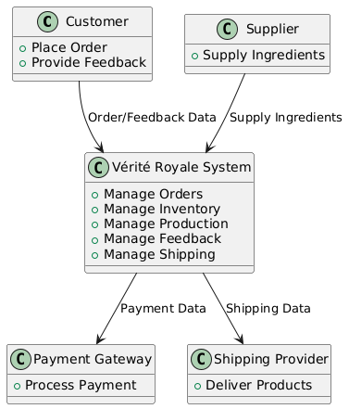

**5.2 Level 1 DFD: First decomposition of the main system**

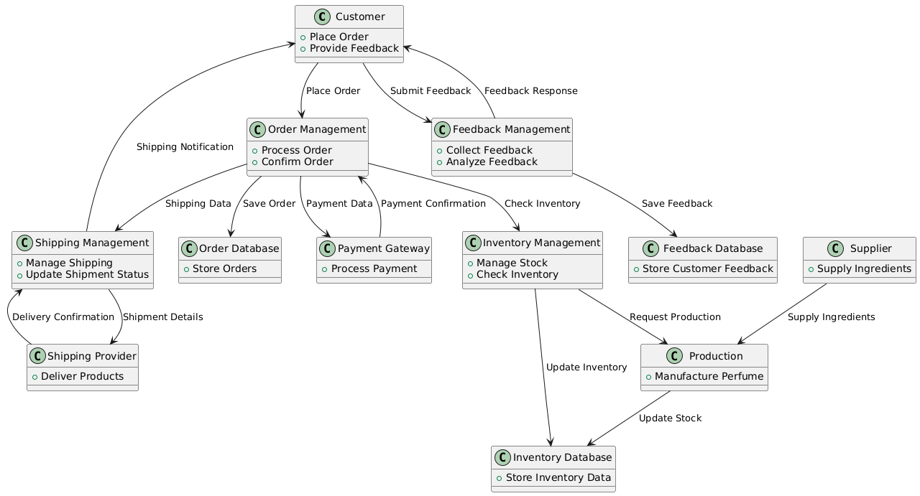

### 5.3 Level 2 DFD

**6. Data Dictionary**

**1.**  **Product Table**

Stores details about the luxury perfumes available in the system.

|  |  |  |  |
| --- | --- | --- | --- |
| **Field Name** | **Data Type** | **Description** | **Constraints** |
| product_id | INT | Unique identifier for each perfume product. | Primary Key,  Auto Increment |
| name | VARCHAR(255) | The name of the perfume. | Not Null |
| brand | VARCHAR(255) | The brand of the perfume. | Not Null |
| description | TEXT | A detailed description of the perfume (notes, ingredients, etc.). | Not Null |
| price | DECIMAL(10, 2) | The price of the perfume in the system's currency. | Not Null |
| stock_quantity | INT | The quantity of the perfume available in stock. | Not Null |
| category | VARCHAR(100) | The category or type of perfume (e.g., floral, woody, oriental). | Not Null |
| image_url | VARCHAR(255) | URL to the image of the perfume. | Optional |
| created_at | DATETIME | Timestamp when the product was added to the system. | Not Null |

### 2. Customer Table

Stores information about customers who register on the platform.

|  |  |  |  |
| --- | --- | --- | --- |
| **Field Name** | **Data Type** | **Description** | **Constraints** |
| customer_id | INT | Unique identifier for each customer. | Primary Key, Auto Increment |
| first_name | VARCHAR(100) | Customer's first name. | Not Null |
| last_name | VARCHAR(100) | Customer's last name. | Not Null |
| email | VARCHAR(255) | Customer's email address. | Not Null, Unique |
| password_hash | VARCHAR(255) | Hashed password for customer login. | Not Null |
| phone_number | VARCHAR(15) | Customer's phone number. | Optional |
| shipping_address | VARCHAR(500) | Shipping address of the customer. | Not Null |
| billing_address | VARCHAR(500) | Billing address of the customer. | Not Null |
| created_at | DATETIME | Timestamp when the customer registered on the platform. | Not Null |

### 3. Order Table

Stores information about customer orders

|  |  |  |  |
| --- | --- | --- | --- |
| **Field Name** | **Data Type** | **Description** | **Constraints** |
| order_id | INT | Unique identifier for each order. | Primary Key, Auto Increment |
| customer_id | INT | Foreign key referencing the customer_id from the Customer table. | Not Null |
| order_date | DATETIME | The date and time when the order was placed. | Not Null |
| total_amount | DECIMAL(10, 2) | The total price of the order (including discounts, taxes, etc.). | Not Null |
| status | VARCHAR(100) | Status of the order (e.g., "Pending", "Shipped", "Delivered"). | Not Null |
| shipping_address | VARCHAR(500) | The shipping address for this specific order (can differ from registered address). | Not Null |
| payment_status | VARCHAR(50) | Payment status (e.g., "Paid", "Pending", "Failed"). | Not Null |
| created_at | DATETIME | Timestamp when the order was placed. | Not Null |

### 4. Payment Table

Stores information related to customer payments.

|  |  |  |  |
| --- | --- | --- | --- |
| **Field Name** | **Data Type** | **Description** | **Constraints** |
| payment_id | INT | Unique identifier for each payment. | Primary Key, AutoIncrement |
| order_id | INT | Foreign key referencing order_id from the Order table. | Not Null |
| payment_date | DATETIME | Date and time of payment. | Not Null |
| payment_method | VARCHAR(50) | The payment method used (e.g., Credit Card, PayPal). | Not Null |
| payment_status | VARCHAR(50) | The status of the payment (e.g., "Completed", "Failed", "Pending"). | Not Null |
| amount | DECIMAL(10, 2) | The amount paid by the customer. | Not Null |
| transaction_id | VARCHAR(100) | The unique transaction ID provided by the payment gateway. | Not Null |

**5.. Inventory Table**

Stores inventory-related information about the perfumes.

|  |  |  |  |
| --- | --- | --- | --- |
| **Field Name** | **Data Type** | **Description** | **Constraints** |
| inventory_id | INT | Unique identifier for each inventory record. | Primary Key, AutoIncrement |
| product_id | INT | Foreign key referencing product_id from the Product table. | Not Null |
| stock_quantity | INT | Current quantity of the perfume in stock. | Not Null |
| last_updated | DATETIME | Timestamp when the inventory was last updated. | Not Null |

**Description of Key Data Fields:**

### Product Table:

* **product_id**: A unique identifier for each product in the system, ensuring that each perfume is uniquely represented in the catalog.
* **name**: The name of the perfume, which is essential for identifying the product.
* **brand**: The brand name associated with the perfume, helping customers to search and filter products based on brand preferences.
* **description**: A detailed description of the perfume, including fragrance notes, ingredients, and other relevant details.
* **price**: The price of the perfume, which is used for calculating the total cost of orders.
* **stock_quantity**: The number of units available in stock, helping to manage inventory and alert the system when stock is low.
* **category**: The category or type of perfume (e.g., floral, woody, oriental), allowing customers to filter products based on their scent preference.
* **image_url**: The URL pointing to an image of the perfume, which is displayed in the product listing and detail page.
* **created_at**: The date and time when the perfume was added to the system, which can be used for sorting or filtering new arrivals.

### 2. Customer Table:

* **customer_id**: A unique identifier for each customer, ensuring that every user's data is stored separately.
* **first_name**: The customer's first name, used for personalized greetings and communication.
* **last_name**: The customer's last name, completing the customer's full identity.
* **email**: The customer's email address, used for communication, order confirmations, and password recovery.
* **password_hash**: The hashed version of the customer’s password, used for secure login.
* **phone_number**: The customer’s phone number, which is an optional but useful piece of information for urgent communication.
* **shipping_address**: The address where the customer’s orders will be delivered, ensuring accurate shipment.
* **billing_address**: The address for billing purposes, which might be different from the shipping address.
* **created_at**: The date and time when the customer account was created.

**3. Order Table**:

* **order_id**: A unique identifier for each order placed by a customer, ensuring each order is tracked independently.
* **customer_id**: A reference to the customer_id from the Customer table, linking the order to the specific customer who placed it.
* **order_date**: The date and time when the order was placed, useful for tracking and sorting orders.
* **total_amount**: The total cost of the order, including taxes, shipping fees, and discounts, calculated from the order items.
* **status**: The status of the order (e.g., "Pending", "Shipped", "Delivered"), which helps in managing the workflow of orders.
* **shipping_address**: The address for shipping the order, which could be the same as or different from the customer's default address.
* **payment_status**: The status of the payment for the order (e.g., "Paid", "Pending", "Failed"), which helps track payment processing.
* **created_at**: The timestamp for when the order was created, allowing for sorting and processing of orders based on their submission time.

### 4. Payment Table:

* **payment_id**: A unique identifier for each payment transaction, ensuring that each payment is tracked independently.
* **order_id**: A reference to the order_id from the Order table, linking the payment to a specific order.
* **payment_date**: The date and time when the payment was processed.
* **payment_method**: The method used for the payment (e.g., "Credit Card", "PayPal", "Bank Transfer").
* **payment_status**: The status of the payment (e.g., "Completed", "Failed", "Pending").
* **amount**: The amount paid by the customer, which should match the total amount of the order.
* **transaction_id**: The unique transaction ID provided by the payment gateway for reference and tracking.
* **created_at**: The timestamp of when the payment was made, useful for tracking payment history.

### 5. Inventory Table:

* **inventory_id**: A unique identifier for each inventory record, allowing tracking of stock levels.
* **product_id**: A reference to the product_id from the Product table, linking the inventory to a specific product.
* **stock_quantity**: The number of units available in stock for the product, which helps ensure proper inventory management.
* **last_updated**: The timestamp of when the inventory was last updated, which helps monitor inventory changes in real time.

**6.1 System Design**

The Vérité Royale is a web-based platform designed to manage perfume sales, customer orders, and product inventory. Below is the breakdown of the system design:

**1. System Architecture**

The system follows a client-server architecture, where the frontend is responsible for interacting with the users, and the backend handles the data processing, storage, and business logic. The application is web-based, allowing access from any modern browser.

**Frontend:**

* React.js, Vue.js are used for creating responsive, user-friendly interfaces.
* The frontend communicates with the backend via API calls (using Node.js, Mongo DB for backend logic).

**Backend:**

* Express routes handle API requests related to user authentication, order management, product management, payment processing, and more.
* The backend processes requests, validates data, communicates with the MongoDB database, and sends appropriate responses back to the frontend.

**2. Data Flow Diagram (DFD)**

A Data Flow Diagram (DFD) helps visualize how data moves through the system. Here’s how the DFD for adding a user might look:

* External Entity: User (Customer)
* Process: User Registration
* Data Store: User Table (Stores username, email, password, role, etc.)
* Data Flow: User details (name, email, password) are entered by the user and sent to the backend for validation and storage in the database.

**3. Database Design**

* The system has multiple tables like Customer, Product, Order, Payment.
* Relationships are established between these tables, such as linking a customer to Order, product.

**4. Module Design**

Each functionality in the system is divided into specific modules, including:

* User Management: Handles user registration, login, and role management.
* Product Management: Allow admins can add, edit, and delete products in the catalog.
* Order Management: Allow customers can place orders, track their order status, and request returns.
* Payment Management: Integration with payment providers such as Stripe or PayPal for secure payment processing.

**5. Security Features**

* User Authentication: Passwords are securely stored (hashed) to prevent unauthorized access.
* Session Management: Users are issued authentication tokens that expire after a set period.
* Role-based Access: Different user roles (Admin, Customers, Staff) are defined, ensuring users have access only to relevant sections.

**6. User Interface Design**

The system provides an intuitive and easy-to-navigate interface, where users can:

* Register as a customer.
* View available perfume stocks.
* Customers can add products to their cart, review items, and adjust quantities before checkout.
* Collects shipping information, allows payment method selection, and provides a clear order summary before completing the purchase.
* Customers can update personal details, manage passwords, and view order history.

**7. Scalability and Maintenance**

* The system is designed to be scalable, allowing more tables and functionalities to be added in the future.
* The codebase is modular, making it easy to maintain and update specific components without affecting the entire system.

**6.2 Scheduling**

The Vérité Royale project follows a structured timeline, ensuring that each phase of development is completed on time. Below is the breakdown of the project schedule, with specific milestones and deadlines tailored to the September to December timeframe.

**1. Project Phases**

The project is divided into several phases to streamline the development process:

**Phase 1: Requirements Gathering and Analysis (September 1st - September 7th)**

* **Activities:**
* Meet with stakeholders to gather functional and non-functional requirements.
* Finalize the list of features, technologies, and design specifications.
* Create initial drafts of the Data Dictionary, Entity-Relationship Diagram, and use cases.
* **Expected Outcome:** A clear understanding of system requirements and project scope.

**Phase 2: System Design (September 8th - September 21st)**

* **Activities:**
* Design the system architecture (frontend, backend, and database).
* Create Data Flow Diagrams (DFD) and system diagrams (e.g., system architecture diagram).
* Plan out the user interface (UI) design, including wireframes.
* **Expected Outcome:** Complete system design documentation, including database and UI wireframes.

**Phase 3: Frontend Development (September 22nd - October 12th)**

* **Activities:**
* Develop the user interface using React, Vue.js along with HTML, CSS, and JavaScript for styling and functionality.
* Implement key features like registration forms, login page, and account management interfaces.
* Test responsiveness and user experience across different device.
* **Expected Outcome:** A fully functional and responsive frontend interface

**Phase 4: Backend Development (October 13th - November 2nd)**

* **Activities:**
* Set up the Node.js backend with Express.js for handling user registration, login, product management, order processing, and customer data management.
* Implement CRUD (Create, Read, Update, Delete) operations for managing product details, user records, orders, and reviews.
* Set up database connections and configure Mongo DB for storing data.
* **Expected Outcome:** A fully functional backend with secure user authentication and management.

**Phase 5: Integration and Testing (November 3rd - November 16th)**

* **Activities:**
* Integrate the frontend and backend components.
* Perform system testing to ensure all features work together as expected.
* Conduct unit testing for individual components and end-to-end testing for user flows (e.g., user registration, order placement, payment).
* Resolve any bugs or issues identified during testing.
* **Expected Outcome:** A fully integrated system with no critical bugs, ready for user acceptance testing.

**Phase 6: User Acceptance Testing (UAT) and Deployment (November 17th - November30th)**

* **Activities:**
* Conduct user acceptance testing with stakeholders (end-users).
* Gather feedback and make necessary adjustments.
* Deploy the application to a live server.
* Provide training to administrators or users if required.
* **Expected Outcome:** Deployed and operational Vérité Royale system, with users trained and the application fully tested

**Phase 7: Maintenance and Updates (December 1st - December 15th)**

* **Activities:**
* Monitor the system for bugs or performance issues.
* Provide updates or enhancements based on user feedback.
* Ensure regular backups and security updates are applied.
* **Expected Outcome:** Long-term stability and performance of the system.

**2. Project Timeline**

Here is the estimated timeline for each phase of the project, starting from September and ending December:

|  |  |  |  |
| --- | --- | --- | --- |
| **Phase** | **Start Date** | **End Date** | **Duration** |
| Requirements Gathering and Analysis | 01/09/24 | 07/09/24 | 1 week |
| System Design | 08/09/24 | 21/09/24 | 2 weeks |
| Frontend Development | 22/09/24 | 12/10/24 | 3 weeks |
| Backend Development | 13/10/24 | 02/11/24 | 3 weeks |
| Integration and Testing | 03/11/24 | 16/11/24 | 2 weeks |
| User Acceptance Testing and Deployment | 17/11/24 | 30/11/24 | 2 weeks |
| Maintenance and Updates | 01/12/24 | 15/12/24 | 2 weeks |

**3. Milestones**

The following milestones mark key points in the project timeline:

* Milestone 1: Completion of System Design (21/09/2024)
* Milestone 2: Frontend and Backend Development Complete (02/11/2024)
* Milestone 3: System Integration and Testing Complete (16/11/2024)
* Milestone 4: Deployment and User Acceptance Testing Complete (30/11/2024)

**4. Resource Allocation**

The following tasks will be distributed between team members:

* Frontend Developer: Responsible for UI design and implementation.
* Backend Developer: Handles PHP programming, database management, and integration.
* Testing and Quality Assurance: Ensures system functionality and conducts testing at various stages.

**6.3 Estimates of Efforts**

**1. Effort Estimation Methodology**

Effort estimates are made by considering the tasks involved, the expected time to complete them, and the skills of the team members. The project phases are designed to follow a logical flow, with each phase building on the previous one. The total estimated effort is calculated by estimating the time each team member will spend on each task.

**2. Effort Breakdown by Phase**

* **Phase 1: Requirements Gathering and Analysis**

Duration: 1 Week Estimated Effort: 40 hours (2 team members)

Activities: Gathering functional and non-functional requirements, preparing the Data Dictionary, Entity- Relationship Diagram, and use cases.

* **Phase 2: System Design**

Duration:2 Weeks

Estimated Effort: 160 hours (2 team members)

Activities: Designing the system architecture, database design, and creating wireframes for the user interface.

* **Phase 3: Frontend Development**

Duration: 3 Weeks

Estimated Effort: 240 hours (2 team members)

Activities: Developing the user interface using React, Vue.js along with HTML, CSS, and JavaScript for styling and functionality.

* **Phase 4: Backend Development**

Duration: 3 Weeks

Estimated Effort: 240 hours (2 team members)

Activities: Developing the Mongo DB backend, integrating with the database, implementing CRUD operations, and security features.

* **Phase 5: Integration and Testing**

Duration: 2 Weeks

Estimated Effort: 160 hours (2 team members)

Activities: Integrating frontend and backend components, performing system testing, unit testing, and bug fixing.

* **Phase 6: User Acceptance Testing and Deployment**

Duration: 2 Weeks

Estimated Effort: 160 hours (2 team members)

Activities: Conducting user acceptance testing, gathering feedback, deploying the application to alive server, and training users

* **Phase 7: Maintenance and Updates**

Duration: 2 Weeks

Estimated Effort: 80 hours (2 team members)

Activities: Monitoring the system, addressing bugs, and providing updates based on user feedback.

**6.4 Modules of Vérité Royale**

**1. Login Module**

The **Login Module** is a secure authentication point for all users interacting with the Vérité Royale system, ensuring that only authorized personnel have access to sensitive data and system features.

* **Purpose**: To authenticate and authorize users before granting access to the system.
* **Features**:
* Login with username and password.
* Multi-factor authentication (MFA) for enhanced security.
* Password recovery and reset functionality.
* Security audit logging for all login attempts and actions.
* **Security**: Passwords are encrypted, and sensitive data is protected using advanced security protocols.

**2. Customer Module**

The **Customer Module** is responsible for maintaining all customer-related information, helping Vérité Royale provide a personalized experience and building long-term relationships.

**Purpose**: To store and manage customer profiles and transaction history.

**Features**:

* Stores personal details (e.g., name, address, contact number, preferences).
* Tracks purchase history and customer loyalty points.
* Captures customer feedback and service ratings.
* Allows for easy updates to personal preferences (e.g., fragrance preferences).
* Provides customers with their loyalty rewards and benefits.
* **Link to Other Modules**: Linked to the **Order Management Module** for tracking purchases and the **Support Module** for handling customer queries.

**3. Product Module**

The **Product Module** manages all details related to Vérité Royale’s luxury perfumes, ensuring that product data is accurate and up-to-date.

**Purpose**: To catalog and manage perfume products, pricing, and availability.

**Features**:

* Catalogs perfume products, including names, descriptions, fragrance notes, and pricing.
* Tracks inventory levels and restocking needs.
* Categorizes perfumes by scent family (e.g., floral, woody, oriental).
* Includes high-quality images, ingredients, and customer reviews for each perfume.
* Allows product updates (new launches, seasonal editions).
* **Link to Other Modules**: Linked to the **Inventory Management Module** to track stock levels and the **Order Management Module** for seamless order processing.

#### 4. Order Management Module

The **Order Management Module** tracks and processes all orders placed by customers, ensuring a smooth flow from order creation to delivery.

**Purpose**: To manage customer orders and ensure timely and accurate delivery.

**Features**:

* Allows customers to place orders, select products, and choose shipping options.
* Tracks order status (e.g., order placed, processing, shipped, delivered).
* Integrates with payment systems for secure transactions.
* Generates invoices, receipts, and order confirmations.
* Handles returns, cancellations, and order modifications.
* **Link to Other Modules**: Tied to the **Customer Module** for customer information and **Product Module** for inventory tracking.

#### 5. Inventory Management Module

The **Inventory Management Module** ensures that Vérité Royale maintains accurate stock levels for all products and efficiently tracks product movement.

**Purpose**: To manage and maintain accurate inventory levels across all perfume products.

**Features**:

* Tracks product availability in real-time.
* Provides alerts for low stock levels and items that need restocking.
* Allows manual adjustments for stock levels (e.g., during inventory audits).
* Generates inventory reports, highlighting trends in stock levels, popular products, and seasonal demand.
* Integrates with the **Product Module** for real-time product updates.
* **Link to Other Modules**: Directly linked to the **Product Module** and **Order Management Module** to update stock as orders are placed.

#### 6. Payment and Billing Module

The **Payment and Billing Module** securely processes all transactions and generates invoices for customer orders.

**Purpose**: To securely handle all financial transactions and billing information.

**Features**:

* Supports multiple payment methods (e.g., credit cards, PayPal, bank transfer).
* Ensures secure encryption of payment data.
* Issues invoices and receipts to customers after successful transactions.
* Tracks payment statuses (paid, pending, failed).
* Provides reporting on payment history and trends.
* **Link to Other Modules**: Linked with the **Order Management Module** to process payments for specific orders.

**7. Source Code**

* **This block of code contains the UI of Login Page**

const handleSubmit = async (e) => {

e.preventDefault();

const {email, password} = data;

if( !email|| !password)

{

return handleError('All Fields are required')

}

try {

const url = "https://veriteroyale.onrender.com/auth/Login";

const response = await fetch(url, {

method:"POST",

headers:

{

'Content-Type': 'application/json'

},

body: JSON.stringify(data)

// validateStatus: (status) => status >= 200 && status < 600, // catch all errors

});

const result = await response.json();

const {sucess, message,jwttoken, name,error,userId} = result;

// console.log(sucess, message);

// console.log(result);

if(sucess)

{

handleSuccess(message);

localStorage.setItem('token',jwttoken);

localStorage.setItem('LoggedInUser',name);

localStorage.setItem('userId',userId);

setTimeout(()=>

{

navigate('/');

},1000);

}

else if(error)

{

const details = error?.details[0].message;

handleError(details);

}

else if(!sucess)

{

handleError(message);

}

} catch (err) {

handleError(err);

}

};

<div className="auth-container">

<h2>Welcome Back!!</h2>

<form onSubmit={handleSubmit}>

<div className="form-group">

<label>Email</label>

<input

type="email"

value={data.email}

name='email'

onChange={handleChange}

required

/>

</div>

<div className="form-group">

<label>Password</label>

<input

type="password"

value={data.password}

onChange={handleChange}

name='password'

required

/>

</div>

<button type="submit" >Login</button>

{/* <button className="reset-password-button" onClick={handlePasswordReset}> Reset Password </button> */}

<Link to="/" className="forgetp" onClick={handlePasswordReset}>Forget Password?</Link>

<Link className='admin' to="/AdminLogin">Admin</Link>

<span> Wanna Join us ?

<Link to="/Regster" className='reg'>Register</Link>

</span>

</form>

<ToastContainer/>

</div>

* **This block of code contains the logic and UI of NAV-bar**

const NavBar = () => {

const [showNavLinks, setShowNavLinks] = useState(false);

const tok = localStorage.getItem('token');

const Uname = localStorage.getItem('LoggedInUser');

const navigate = useNavigate();

const handleToggleMenu = () => {

setShowNavLinks(prev => !prev);

};

const handleLogout = ()=>{

localStorage.removeItem("token");

localStorage.removeItem("name");

localStorage.removeItem("userId");

//window.location.reload();

navigate('/');

}

return (

<nav className="nav-bar">

<div className="hamburger-menu">

<div className="hamburger-icon"

onClick={handleToggleMenu}

aria-expanded = {showNavLinks}

aria-label="Toggle menu">

<span></span>

<span></span>

<span></span>

</div>

</div>

<ul className={nav-links ${showNavLinks ? 'show-nav-links' : ''}} id='left'>

<li><Link to="/Fragrances">Fragnances</Link></li>

<li><Link to="/NewArrivals">New Arrivals</Link></li>

<li><Link to="/OurWorld">Our World</Link></li>

</ul>

<div className="logo">

<Link to={"/"}><h1>VÉRITÉ ROYALE</h1> </Link>

</div>

<ul className={nav-links ${showNavLinks ? 'show-nav-links' : ''}} id='right'>

<li><Link to="/Services">Custom</Link></li>

<li><Link to="/Stories">Stories</Link></li>

{/* <li>

<Link to="/Fragrances">

<img src={perfume} alt="Icon" style={{ width: '30px', height: '30px' }} />

</Link>

</li> */}

<li>

{tok == null ? (

<Link to="/Login">

<img src={user} alt="Icon" style= {{ width: '30px', height: '30px' }} />

</Link>

) : (

<div className="dropdown">

<button className="dropbtn">

{Uname} <FaUserCheck/>

</button>

<div className="dropdown-content">

<Link to="/Cart">Cart</Link>

<Link onClick={handleLogout}>Logout</Link>

</div>

</div>

)}

</li>

</ul>

</nav>

* **This block of code contains the logic and UI of user cart**

<div className="cart-container">

<h1>Your Cart</h1>

{cartItems.length === 0 ? (

<p>Your cart is empty</p>

) : (

<>

{cartItems.map((item) => (

<div key={item.productId} className="cart-item">

<img

src={https://veriteroyale.onrender.com/${item.imageUrl}}

alt={item.name}

/>

<div className="item-details">

<h3>{item.name}</h3>

<p>Price: ₹{item.price}</p>

<div className="quantity-control">

{/* <button onClick={() => updateQuantity(item.productId, item.quantity - 1)} disabled={item.quantity === 1}>-</button> */}

<span>{item.quantity}</span>

{/* <button onClick={() => updateQuantity(item.productId, item.quantity + 1)}>+</button> */}

</div>

<button onClick={() => removeItem(item.productId)}>Remove</button>

</div>

</div>

))}

<div className="cart-summary">

<h2>Total: ₹{total.toFixed(2)}</h2>

<button

onClick={handleCheckout}

className="checkout-button"

>

Proceed to Checkout

</button>

</div>

</>

)}

</div>

* **This block of code contains the logic and UI of Frangrances.**

const fetchFragrances = async () => {

try {

const response = await axios.get('https://veriteroyale.onrender.com/api/getAll');

setFragrances(response.data);

} catch (error) {

handleError('OOPS!! Something went Wrong....');

}

};

fetchFragrances();

}, []);

<div className="fragrances-container">

<div className="fragrances-grid">

{fragrances.map((fragrance) => (

<div key={fragrance.id} className="fragrance-card">

<img

src={https://veriteroyale.onrender.com/${fragrance.imageUrl}}

alt={fragrance.name}

/>

<h2>{fragrance.name}</h2>

<p>{fragrance.description}</p>

<br />

{tok == null ? (

''

) : (

<button

onClick={() => addToCart(fragrance)}

className="cart-icon-button"

>

<FontAwesomeIcon

icon={faShoppingCart}

className="cart-icon"

/>

</button>

)}

</div>

))}

</div>

* **This block of code contains the logic and UI of feedback.**

const handleSubmit = async (e) => {

e.preventDefault();

try {

await axios.post('https://veriteroyale.onrender.com/stories/createstories', newStory);

setNewStory({ name: '', feedback: ''});

setShowForm(false);

fetchStories();

} catch (error) {

console.error('Error submitting story:', error);

}

};

return (

<div className="stories-container">

<button

className="write-story-btn"

onClick={() => setShowForm(!showForm)}

>

{showForm ? 'Close Form' : 'Share Your Story'}

</button>

{showForm && (

<form className="story-form" onSubmit={handleSubmit}>

<input

type="text"

placeholder="Your Name"

value={newStory.author}

onChange={(e) => setNewStory({...newStory, name: e.target.value})}

required

/>

<textarea

placeholder="Share your experience..."

value={newStory.feedback}

onChange={(e) => setNewStory({...newStory, feedback: e.target.value})}

required

/>

<button type="submit">Submit Story</button>

</form>

)}

{/* <h1>Customer Stories</h1> */}

<div className="stories-cloud">

{stories.map((story, index) => (

<div

key={story._id || index}

className="story-bubble"

style={{

animationDelay: ${index * 0.2}s,

transform: rotate(${Math.random() * 10 - 5}deg)

}}

>

{/* <h3>{story.title}</h3> */}

<p>"{story.feedback}"</p>

<span className="author">- {story.name}</span>

</div>

))}

</div>

</div>

* **This Block of Code contains UI of Admin Dashboard**

<div className="dashboard">

<Sidebar />

<div className="main-content">

<h1>VÉRITÉ ROYALE | c'est du luxe</h1>

<div className="cards">

<div className="card">

<h2>Products</h2>

<p>{productsCount}</p>

</div>

<div className="card">

<h2>Users</h2>

<p>{usersCount}</p>

</div>

<div className="card">

<h2>Stock</h2>

<p>{stock}</p>

</div>

<div className="card">

<h2>Sale</h2>

<p>₹ {sale}</p>

</div>

<div className="card">

<h2>Total Value</h2>

<p>₹ {totalprice}</p>

</div>

<div className="card">

<h2>Orders</h2>

<p>{Order}</p>

</div>

</div>

</div>

</div>

* **This Block of Code contains UI of purchase order made by Users.**

<table border={1} cellPadding={10} cellSpacing={0}>

<thead>

<tr>

<th>Order ID</th>

{/* <th>User ID</th> */}

<th>User Name</th>

<th>Email</th>

<th>Product Name</th>

<th>Quantity</th>

<th>Price (₹)</th>

<th>Total (₹)</th>

<th>Order Date</th>

<th>Status</th>

</tr>

</thead>

<tbody>

{orders.map((order) => (

<tr key={order.orderId}>

<td>{order.orderId}</td>

{/* <td>{order.userId}</td> */}

<td>{order.userName}</td>

<td>{order.userEmail}</td>

<td>{order.productName}</td>

<td>{order.quantity}</td>

<td>{order.price}</td>

<td>{order.quantity * order.price}</td>

<td>{new Date(order.orderDate).toLocaleDateString()}</td>

<td>{<select

name="size"

value={order.status}

// onChange={handleChange}

required

>

{/* <option value="">Select size</option> */}

<option value="pending">Pending</option>

<option value="">Dispatched</option>

</select>}</td>

</tr>

))}

</tbody>

</table>

* **This Block of code contain the product details for Admin Control.**

<div className="ProductTable">

{/* <Link className="ADDP" to={"/add"}>Add Product</Link> */}

<h1>Products </h1>

<table border={1} cellPadding={10} cellSpacing={0}>

<thead>

<tr>

<th>S.NO.</th>

<th>Product Name</th>

<th>Price ($)</th>

<th>Stock</th>

<th>Description</th>

<th>Image</th>

<th>Actions</th>

</tr>

</thead>

<tbody>

{

products.map((product, index)=>

{

return(

<tr key={product._id}>

<td>{index+1}</td>

<td>{product.name} </td>

<td>{product.price}</td>

<td>{product.stock}</td>

<td>{product.description}</td>

<td><img src={https://veriteroyale.onrender.com/${product.imageUrl}} alt={product.name} /></td>

<td>

<Link to={/edit/+product._id} className="button-link">Update</Link>

<button onClick={()=>deleteProduct(product._id)}>

Remove</button>

</td>

</tr>

)

}

)}

</tbody>

</table>

* **This Block of Code represents the logic of editing the product by the Admin.**

const submitForm = async (e) => {

e.preventDefault();

const form = new FormData();

if(imagefile) {

form.append("imageUrl", imagefile);

}

form.append("name", product.name);

form.append("description", product.description);

form.append("price", product.price);

form.append("stock", product.stock);

form.append("discount", product.discount);

try {

await axios.put(https://veriteroyale.onrender.com/api/update/${id}, product);

handleSuccess({msg:"Product Updated Successfully!!.."});

navigate("/ViewProduct");

} catch (error) {

handleError({msg:"Error updating product"});

console.log(error);

}

};

* **This Block of Code deals with the logic of sending any mail.**

async function sendMail(to,subject,text) {

// send mail with defined transport object

const info = await transporter.sendMail({

from: '" Verite Royale "<royaleverite@gmail.com>', // sender address

to,

subject,

text,

// html: "<b>Hello world?</b>", // html body

});

* **This is the Schema of Database.**

const ProductSchema = new Schema({

name: {

type: String,

required: true

},

description: {

type: String,

required: true

},

price: {

type: Number,

required: true

},

imageUrl: {

type: String,

required: true

},

stock: {

type: Number,

required: true,

default: 0

}

});

* **This shows the routing**

const { signup, login, getUsers, usersCount, adminLogin, deleteuser, resetPassword, resetPasswordConfirm } = require("../controllers/AuthController");

const { signupValidation, loginValidation } = require("../middlewares/Authvalidation");

const router = require("express").Router();

router.post("/reset-password/confirm", resetPasswordConfirm)

router.post("/reset-password", resetPassword)

router.post("/Login",loginValidation,login)

router.post("/Regster",signupValidation,signup)

router.get("/getUsers", getUsers);

router.get("/usersCount",usersCount);

router.post("/adminLogin",loginValidation,adminLogin)

router.delete("/deleteuser/:id",deleteuser);

* **This Block of Code contains the logic of user registration.**

const signup = async(req,res)=>

{

try {

const {name, email, password} = req.body;

const user = await UserModel.findOne({email});

if(user)

{

return res.status(409)

.json({message: "You are already connected with us!!", sucess: false});

}

const userModel = new UserModel({name, email, password});

userModel.password = await bcrypt.hash(password,10);

await userModel.save();

const emailContent = `

Dear ${name},

We are absolutely delighted to welcome you to the Royale Verite community!

Thank you for choosing us to accompany you on your journey into the world of luxury fragrances.

What to Expect:

Exclusive Offers: As a valued member, you will receive special promotions and discounts tailored just for you.

Insider Tips: Stay tuned for expert advice on how to choose and wear our exquisite perfumes to enhance your personal style.

New Arrivals: Be the first to know about our latest fragrance launches and collections.

Getting Started:

To help you dive into our luxurious offerings, we recommend checking out:

Our Bestsellers: Discover the fragrances that our customers adore. https://veriteroyale.netlify.app/Fragrances

Fragrance Guide: Learn about different scent families and find your perfect match. [Link to guide]

Join Our Community: Connect with fellow fragrance enthusiasts on our social media platforms. [Links to social media]

If you have any questions or need assistance, please don’t hesitate to reach out. Our dedicated team is here to ensure you have an exceptional experience with Royale Verite.

Once again, welcome! We can’t wait for you to explore our luxurious scents and find the perfect fragrance that resonates with you.

Warm regards,

Royale Verite Team

`;

sendMail(email,"Welcome to the Royale Verite Family!", emailContent)

const jwttoken = jwt.sign({email: userModel.email, _id: userModel._id},

process.env.JWTPRIVATEKEY,

{expiresIn:'24h'}

)

res.status(201)

.json({

message: "Welcome to Verite Royale..",

sucess: true,

jwttoken,

email,

name:userModel.name,

userId:userModel._id

})

} catch (error) {

console.log(error);

res.status(500)

.json({message: "OOPS! something went Wrong",

sucess: false})

}

}

**Output**

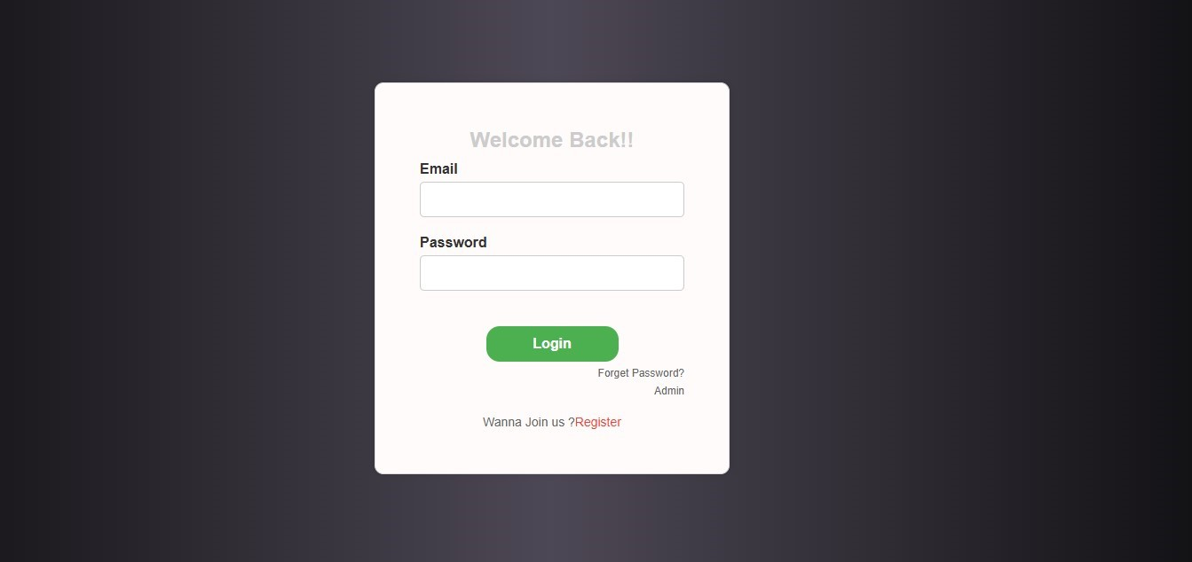

**In the above fig 7.1 shows the Login page, if the user wants to login, they must enter valid/registered username and password and click on login button.**

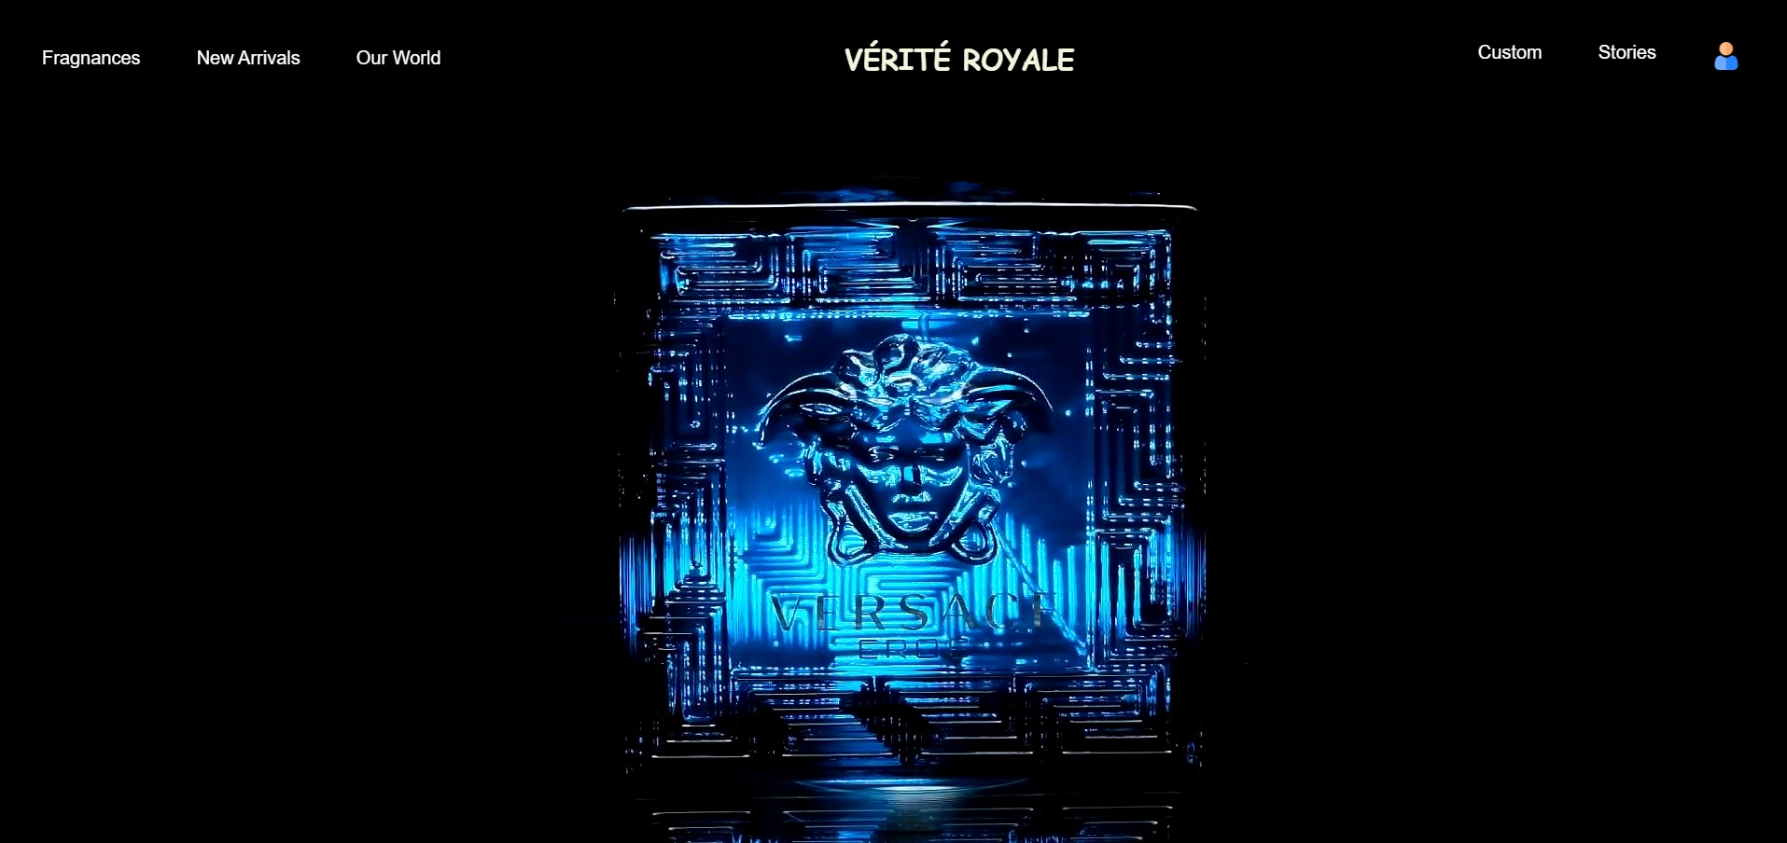

**In the above fig 7.2 shows the Home page of Vérité Royale**

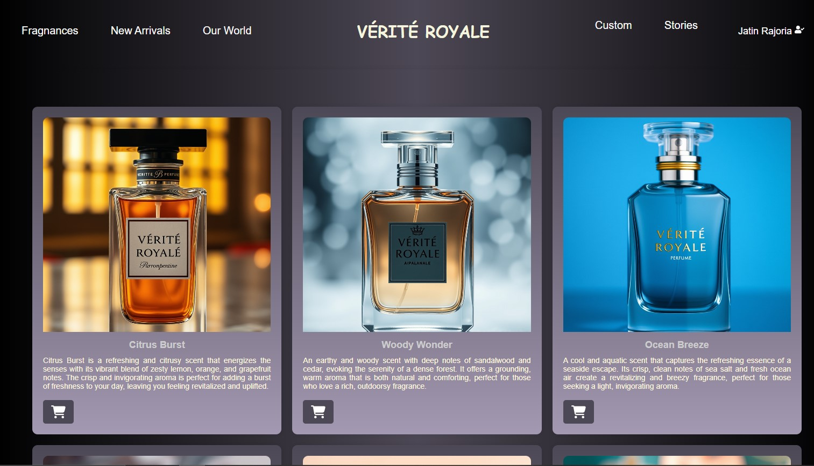

**In the above fig 7.3 shows the Frangrances page of Vérité Royal**

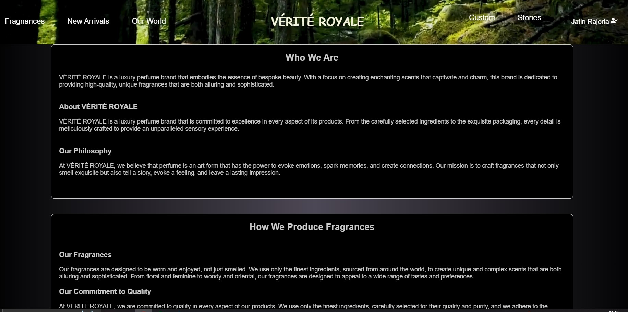

**In the above fig 7.4 shows the Our World page of Vérité Royale**

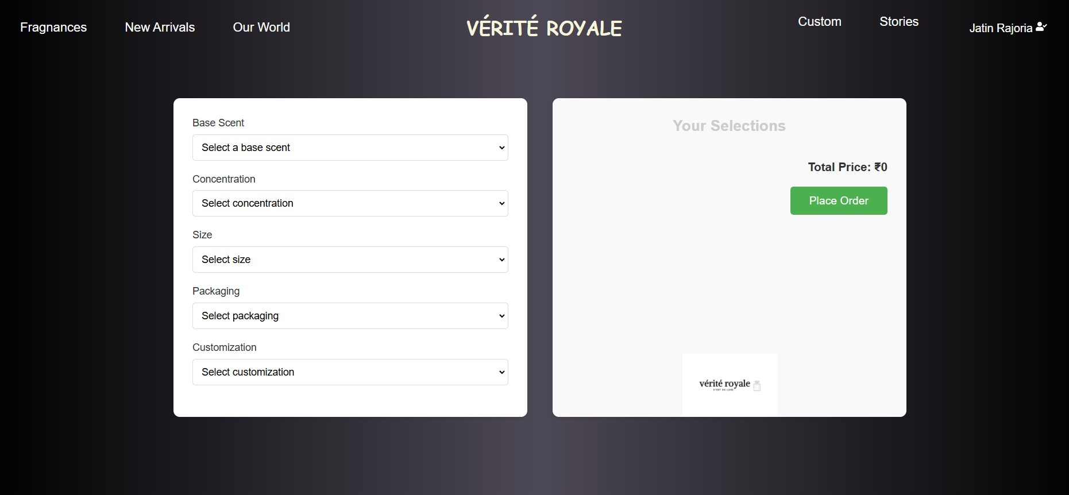

**In the above fig 7.5 shows the Custom page of Vérité Royale**

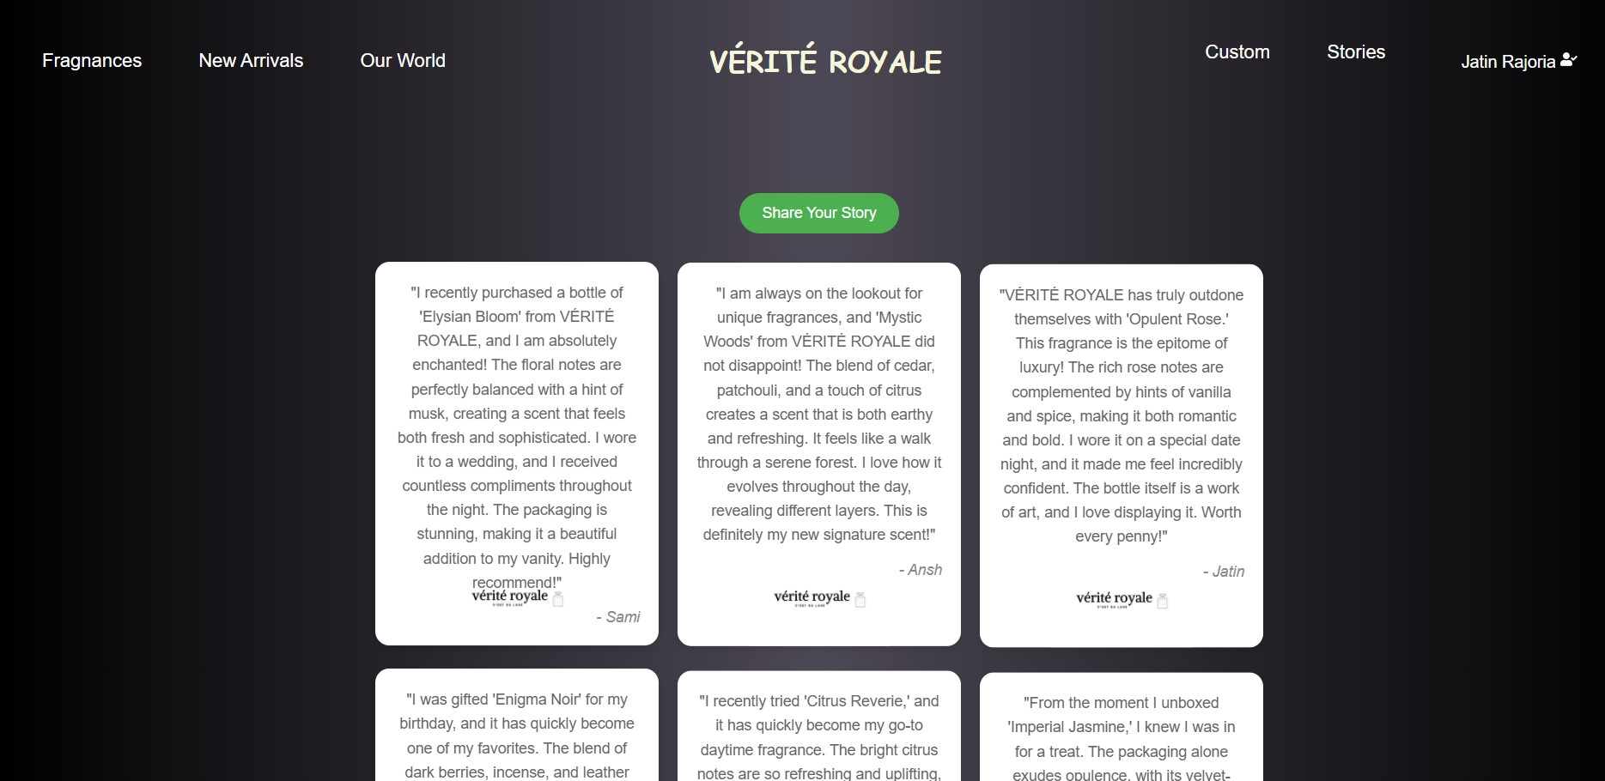

**In the above fig 7.6 shows the Stories page of Vérité Royale**

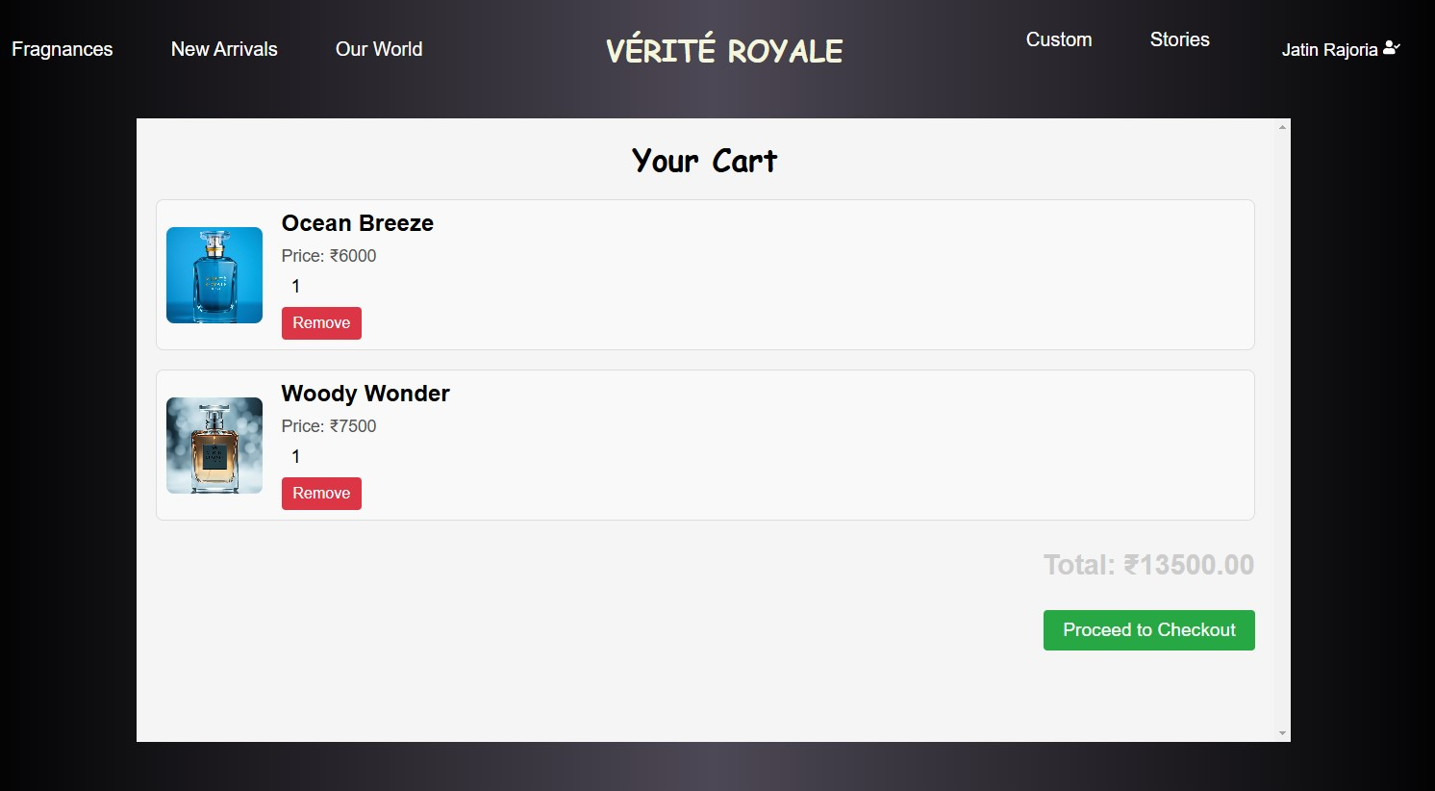

**In the above fig 7.7 shows the Cart page of Vérité Royale**

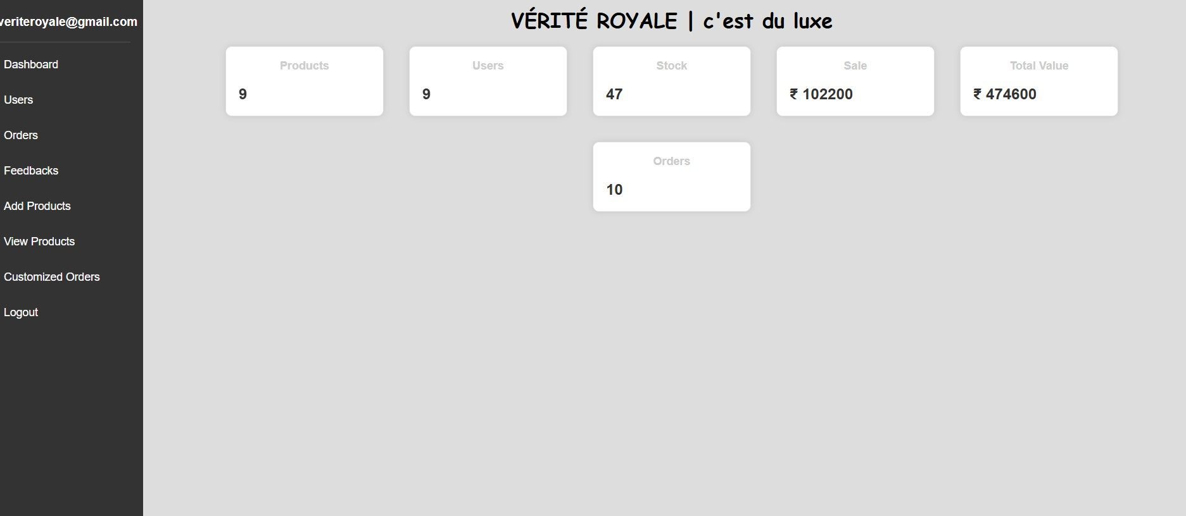

**In the above fig 7.8 shows the Dashboard page of Vérité Royale**

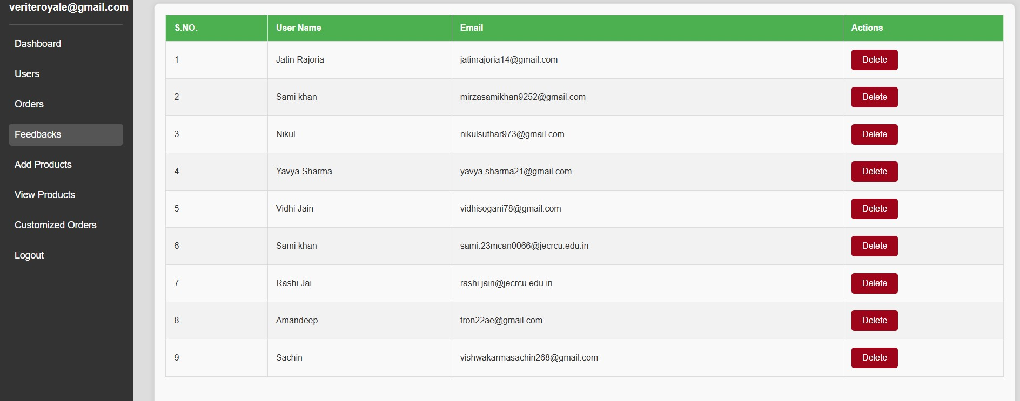

**In the above fig 7.9 shows the Users page of Vérité Royale**

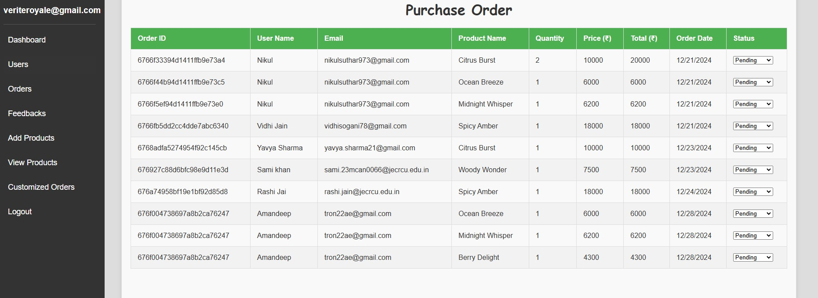

**In the above fig 7.10 shows the Orders page of Vérité Royale**

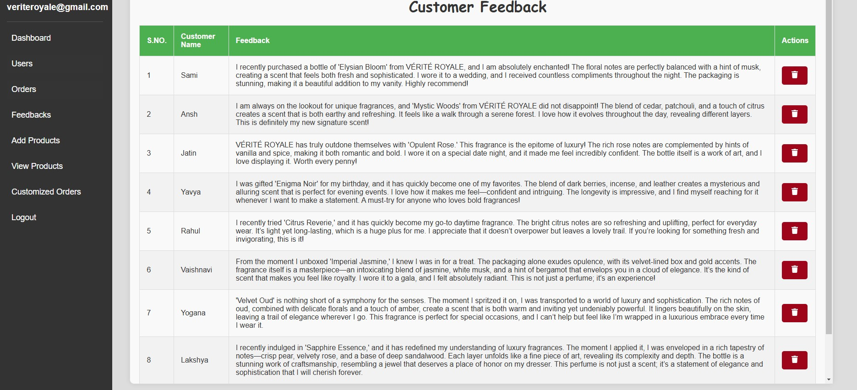

**In the above fig 7.11 shows the Customer Feedback page of Vérité Royale**

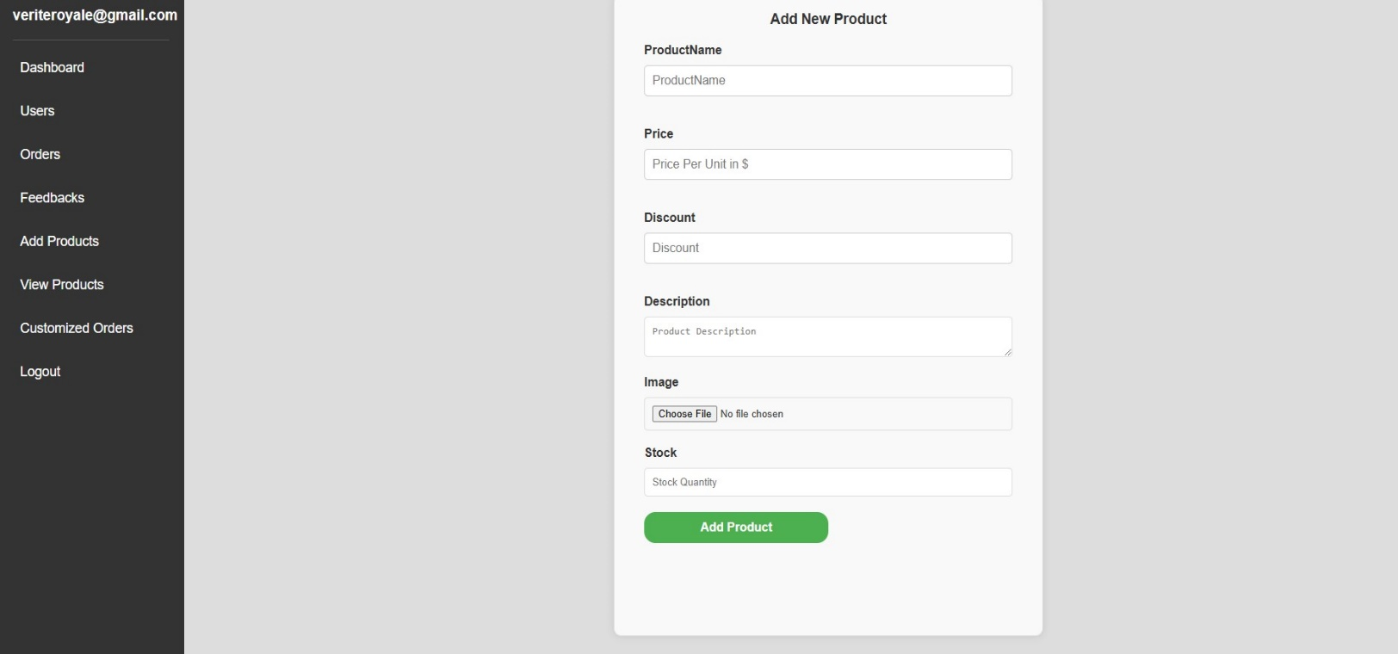

**In the above fig 7.12 shows the Add Products page of Vérité Royale**

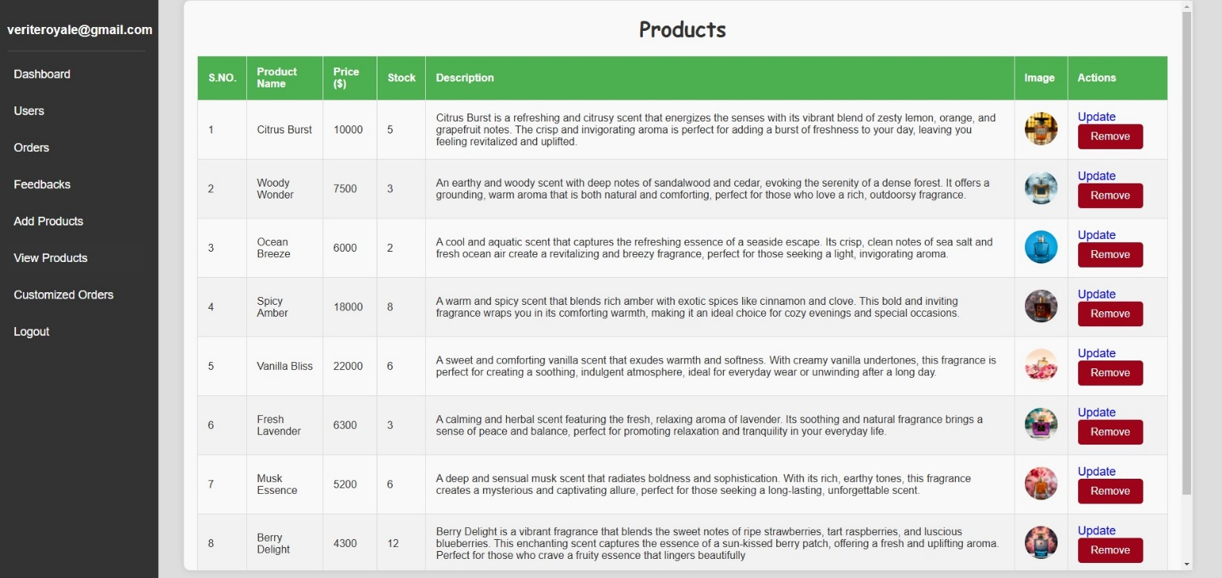

**In the above fig 7.13 shows the Customized Orders page of Vérité Royale**

**8. Limitations and Future Enhancements**

Vérité Royale, as a luxury perfume brand, has established itself in the high-end market with an emphasis on quality, craftsmanship, and exclusivity. While the brand is successful, there are certain limitations that, if addressed, could elevate the customer experience, increase operational efficiency, and expand the brand’s presence. Below are the current limitations and potential future enhancements.

**Limitations**

1. **Limited Product Availability**

* **Current Limitation:** Vérité Royale offers a limited number of fragrances, which may restrict customer choice and exclude potential buyers seeking variety.
* **Future Solution:** Expand the fragrance portfolio by introducing seasonal or limited-edition scents, providing more variety while maintaining the brand's exclusivity.

1. **Limited Customer Engagement and Loyalty Programs**

* **Current Limitation:** The brand does not currently offer loyalty or rewards programs to engage its high-end clientele.
* **Future Solution:** Introduce an exclusive VIP loyalty program where customers receive access to limited-edition perfumes, personalized recommendations, early access to new launches, and exclusive events.

1. **Inflexible Pricing Structure**

* **Current Limitation:** Vérité Royale’s perfumes are typically priced at a high premium, making them less accessible to a wider audience.
* **Future Solution:** Introduce a tiered pricing model with more affordable options (e.g., smaller sizes or travel sprays) to allow new customers to experience the brand without committing to the full-size, high-priced offerings.

**Future Enhancements**

1. **Scent Subscription Service**

* **Feature:** Introduce a luxury scent subscription box, where customers receive a curated selection of miniature or travel-sized versions of Vérité Royale perfumes on a regular basis.
* **Benefits:** Increases brand engagement and allows customers to explore different scents while generating recurring revenue.

1. **Exclusive Members-Only Events**

* **Feature:** Host members-only events or private perfume launch parties, either online or in luxurious venues, where clients can interact with the brand’s creators and learn about the artistry behind fragrance creation.
* **Benefits:** Strengthens customer loyalty, fosters a sense of exclusivity, and deepens the connection between the brand and its elite clientele.

1. **Advanced Customer Service & Consultation**

* **Feature:** Offer personalized fragrance consultations via video chat or in-person appointments with master perfumers to help customers select a scent that perfectly matches their style, lifestyle, or occasion.
* **Benefits:** Provides an exceptional, high-touch customer experience that aligns with the luxury nature of the brand, improving both satisfaction and retention.

1. **Sustainability Certification and Transparency**

* **Feature:** Obtain certifications for sustainability practices (e.g., Cruelty-Free, Fair Trade, Carbon Neutral) and provide customers with transparency about ingredient sourcing and environmental impact.
* **Benefits:** Strengthens the brand’s reputation for ethical luxury, appealing to increasingly conscious consumers who value environmental and social responsibility.

1. **Fragrance Layering Guide**

* **Feature:** Develop a guide or app that suggests how to layer different Vérité Royale perfumes to create unique, personalized scents.
* **Benefits:** Encourages experimentation and promotes the versatility of the brand’s offerings, making it more appealing to customers who want to customize their fragrance experience.

**Conclusion**

Vérité Royale has firmly established itself as a leader in the luxury perfume industry, offering exceptional fragrances that embody sophistication and craftsmanship. However, future enhancements such as personalized perfume experiences, expanded digital presence, sustainability initiatives, and exclusive customer engagement programs can further elevate the brand's appeal. By embracing innovation in both product offerings and customer experience, Vérité Royale can continue to set new standards in luxury perfumery, strengthening its connection with discerning customers and ensuring its legacy as a symbol of elegance and exclusivity.